Crystallization behavior of BaO–CaO–SiO₂–B₂O₃ glass sealant and adjusting its thermal properties for oxygen transport membrane joining application
Xinfang Li^{1, 4,} *, Elena Yazhenskikh², Sonja M. Groß-Barsnick ^{1,} *, Stefan Baumann³, Patrick Behr³, Wendelin Deibert³, Thomas Koppitz¹, Michael Müller², Wilhelm A. Meulenberg^{3, 5}, Ghaleb Natour^{1, 4}
¹ Central Institute of Engineering, Electronics and Analytics – Engineering and Technology (ZEA-1), Forschungszentrum Jülich GmbH, Jülich, Germany
² Institute of Energy and Climate Research – Microstructure and Properties of Materials (IEK-2), Forschungszentrum Jülich GmbH, Jülich, Germany
³ Institute of Energy and Climate Research – Materials Synthesis and Processing (IEK-1), Forschungszentrum Jülich GmbH, Jülich, Germany
⁴ Faculty of Mechanical Engineering, RWTH Aachen University, Aachen, Germany
⁵ Faculty of Science and Technology, Inorganic Membranes, University of Twente, Enschede, The Netherlands
*Corresponding author: Xinfang Li, xinfang.li@rwth-aachen.de and Sonja M. Groß-Barsnick, s.m.gross@fz-juelich.de

Abstract
In this work, the thermal stability of a BaO–CaO–SiO₂–B₂O₃ glass sealant, named “H”, was investigated by differential scanning calorimetry (DSC). The crystallization behavior of glass H as the sealant matrix was investigated by a combination of experimental X-ray diffraction (XRD) analysis and thermodynamic simulation with the FactSage package. A good agreement was found between the Rietveld refinement of XRD experiments and the FactSage simulation. Particular attention was also given to the influence of the Sr₂SiO₄ filler added to the glass matrix “H” on the thermal expansion and microstructures of glass-Sr₂SiO₄ composites by means of dilatometry and scanning electron microscopy (SEM). The reinforced 20 wt.% Sr₂SiO₄ composite showed excellent properties and, thus, its joining performance was investigated using SrTi_{0.75}Fe_{0.25}O_{3-δ} (STF25) and Aluchrom as promising membrane and counterpart, respectively. The joining behaviors were investigated by comparing different joining temperatures. 920 °C is the best joining temperature for HS2S20 sealant.

Keywords: Glass sealant, crystallization, CTE, joining, OTM

1. Introduction
Oxygen transport membrane (OTM) technology is prospected for CO₂ capture from exhaust gas or for producing synthesis gas and commodity chemicals from captured CO₂ and steam or hydrocarbons [1, 2]. This is a good strategy for alleviating the environmental burden from greenhouse gases [3]. For instance, SrTi_{0.75}Fe_{0.25}O_{3-δ} perovskite membrane has been developed since 2009 [4] and is considered to be one of the promising candidates for OTM applications due to its favorable oxygen semi-permeation, excellent mechanical properties and high chemical stability in working environments [5-7]. In an OTM module stack, gastight sealants with suitable and adjusted thermal expansion must be applied to join membranes and counterparts in order to prevent gas mixing during high temperature operation, which is also a key challenge in the module design.
Glass sealants have been developed and studied extensively, as they are promising joining materials with tailorable composition and thermal properties [8-10]. In addition, glass sealants are commonly not affected by oxidizing or reducing atmospheres and exhibit good heat resistance at temperatures above 700 °C [11, 12]. The joining process is achieved by the viscous flow of the glass above glass softening temperature, resulting in the wetting of the ceramic membrane and metal counterparts. Moreover, it is possible to increase the formation of crystalline phases and reduce the glassy phase through a suitable thermal treatment for glass sealants in order to tailor the creep behavior of the glass. However, glass crystallization is difficult to control during heating for multi-element complex glass systems, and the crystalline phases may affect sealing performance. The thermal expansion behavior of a glass-ceramic sealing material partly depends on the thermal expansion of the crystalline phases precipitated from the glass. A low thermal expansion and the change in thermal properties caused by the crystallization of the glass could lead to cracking and gas-leakage during joining or subsequent OTM operation above 700 °C [13]. Knowledge of the crystallization behavior of the glass sealant is therefore essential for high temperature joining and long-term operation.
However, the development of composites is still based on empirical intuitive approaches. No studies have been carried out to simulate the crystallization behavior of glass sealants. Computational modelling the crystallization behavior of glass sealant is of great interest for the optimization of thermal properties. The thermochemical software package FactSage (GTT-Technologies, Germany) is one of the largest fully integrated database computing systems in chemical thermodynamics for inorganic systems in the world [14, 15]. By using this commercial software FactSage, it is possible to simulate and predict the potential phases formed in the glass sealant under equilibrium conditions depending on the applied temperature. FactSage has often been used to simulate crystalline phase equilibrium versus temperature in industrial wastes, such as slags and fly ash [16-18].
Barium calcium silicate glass “H” was investigated as a sealant matrix for joining OTMs due to its excellent viscosity, chemical compatibility, and joining properties demonstrated in solid oxide fuel cell (SOFC) applications at Forschungszentrum Jülich [19]. Glass “H” has a composition based on the BaO–CaO–SiO₂–B₂O₃ system with a small amount of Al₂O₃, ZnO₂, and V₂O₅ additive [20].V₂O₅ acts as glass modifier and creates more open glass network therefore increases thermal expansion behavior of glass sealant [21-23]. Small addition of V₂O₅ in glass sealant is also beneficial for reducing surface tension, viscosity and joining temperature (below 1000 °C), which could make good wetting and sealing behavior with OTM and counterpart alloy [23-25].
Brendt et al. [24] recently reported on the crystallization behavior of glass H for SOFC only below the temperatures of 850 °C. The observation or simulation of the crystallization behavior of glass H at temperatures relevant to OTM applications and other high temperature processes ≥ 850 °C has not yet been reported in the literature. Moreover, a shortcoming of glass H is its relatively low coefficient of thermal expansion (CTE) compared to STF25 membrane materials and counterpart alloy. Thermal expansion mismatch can lead to thermal stresses, resulting in cracking and delamination of the samples, which in turn causes the module to leak gas. According to the state of the art, there are two methods to overcome pure glass low CTE problem [26, 27]. First strategy is to make a homogenous glass crystallization and form a high CTE phase in glass, which is called “crystallization joining”. Second method is to add high CTE filler materials into the glass, which is denoted as “composite joining”. But, it’s not easy to get the desired high CTE phases only by crystallizing glass in many cases. Low CTE phases maybe form in glass during heat treatment. Adding filler materials with a higher CTE into the glass matrix is a feasible strategy for improving the CTE of glass H (9.6 × 10⁻⁶ /K) in order to obtain adapted CTEs (around 12 × 10⁻⁶ /K) with the membrane and the metallic counterpart [20]. Furthermore, the FactSage thermodynamic simulation for glass H could also provide innovative ideas to improve the CTE of the glass sealant for further investigations.
The properties of glass-based sealants can be tailored for OTM sealing by adding filler materials [28, 29]. The strontium silicate (Sr₂SiO₄) used in this study exhibits a CTE (12.8 × 10⁻⁶ /K) [30] in a suitable range for sealing the materials of components for high temperature OTM applications. It can be assumed that the addition of filler materials in combination with other crystalline phases formed in glass and residual amorphous phases can adjust the CTE of the sealant to an appropriate value. Moreover, the diffusion at the interface between the glass sealant and the STF25 membrane can possibly be reduced by reducing the chemical gradient between the components [31] as the filler has the same element, Sr, as the STF25 membrane. When Sr₂SiO₄ fillers are added to the glass H matrix, good compatibility with the other components of the STF25 membrane stack and adapted thermal expansion can be expected for this new glass-ceramic composite sealant.
Some literatures reported that Cr-containing alloys like Crofer 22 APU have the challenges of evaporation of Cr⁶⁺ species and formations of high CTE phase with glass ceramic sealants like BaCrO₄ and SrCrO₄ [32-34]. Aluchrom is a ferritic steel with Cr composition 19-22% and Al 6%. At high temperature, Aluchrom formed Al₂O₃ scale layer which could offer as a protective layer to prevent Cr evaporation [35]. Aluchrom is good candidate used in OTM application as counterpart alloy [29].
Therefore, in this study, thermal stability, thermal expansion, and the crystallization behavior of glass matrix H of the barium–calcium–silicate system were investigated by differential scanning calorimetry (DSC), dilatometry, and X-ray powder diffractometry (XRD), respectively. FactSage simulations were performed to plot the phase equilibrium and to predict crystalline phases versus temperature for the composition of glass H. Against this backdrop, the filler material Sr₂SiO₄ was added to glass H in order to adjust the CTE of the composites by changing the amount of the Sr₂SiO₄ additive. The shrinkage behavior of the glass composite was examined by means of hot stage microscopy (HSM) investigating the viscous flow behavior and optimum joining temperature for OTM application. Finally, the effect of temperature on the joining behavior of the glass composite sealant was investigated by gas leakage measurements and microstructural analysis with scanning electron microscopy (SEM) on cross sections of the joints with the STF25 membranes and Aluchrom plates.

2. Experimental
Glass H based on a BaO–CaO–SiO₂–B₂O₃ composition was fabricated by melting a batch mixture of alkaline-earth carbonates, boric acid, silica, and other additional oxides. The composition is listed in Table 1. The batch was molten in a platinum crucible in air at 1500 °C for 2 hours before quenching in ice water, rinsing in acetone and drying in a heating chamber at 60 °C over night. The glass frits were ground into a median particle size of 10–13 µm powder using a planetary ball mill with agate mortar (Fritsch Pulverisette). The heat resistant ferritic steel used as a counterpart for this work was Aluchrom Y Hf 1.4767 (VDM Metals International GmbH), containing 19–22% chromium, 5.5–6.5% aluminum, and alloyed with yttrium and hafnium (<0.1% each).
Table 1. Glass H chemical composition
Composition | BaO | SiO₂ | CaO | B₂O₃ | Additives
mol% | 28.5 | 44.5 | 9.7 | 9.9 | ZnO, Al₂O₃, V₂O₅
wt.% | 48.2 | 29.8 | 6.1 | 7.6

For the glass composites, the ceramics filler material Sr₂SiO₄ was added with different weight percentages to the glass H matrix to improve the thermal expansion properties. Sr₂SiO₄ was produced by mixing raw materials SrCO₃ and SiO₂ in the correct stoichiometry, followed by sintering at 1350 °C for 30 h. The raw materials were purchased from Merck KGaA (Germany) and had a grade of purity higher than 99%. The compositions of the composites and their abbreviations are listed in Table 2. The mean particle size of Sr₂SiO₄ is about 12.1 µm, as determined by laser particle size analysis (LA950 V2, Retsch). For better mixing, glass H and filler powders were blended in a mechanical shaker (Willy A. Bachofen AG Maschinenfabrik, T2C) for 30 min.
Table 2. Abbreviations of glass ceramic composites
Abbrev. | Glass H | Fillers
HS2S10 | 90 wt.% | Sr₂SiO₄ 10 wt.%
HS2S20 | 80 wt.% | Sr₂SiO₄ 20 wt.%
HS2S30 | 70 wt.% | Sr₂SiO₄ 30 wt.%
HS2S40 | 60 wt.% | Sr₂SiO₄ 40 wt.%

Differential scanning calorimetry (DSC) measurement was carried out for glass H powders. A commercial DSC instrument Linseis (STA PT 1600) was employed with a heating rate of 15 °C/min up to 1300 °C in an alumina crucible in an air atmosphere. The phase transition temperatures were measured under this apparatus within an accuracy of ± 2 °C. Glass transition temperature (T_{g}), onset crystallization (T_{r}), crystallization peak temperature (T_{p}), and onset melting temperature (T_{m}) were determined. The glass-forming tendency and the thermal stability against crystallization of glass H were evaluated using DSC data in accordance with Hurbý’s equation [36] (e.1), which is based on the relative onset temperatures T_{g}, T_{r}, and T_{m}:
$K_{gl}=\frac{T_{r}-T_{g}}{T_{m}-T_{r}}$$K_{gl}=\frac{T_{r}-T_{g}}{T_{m}-T_{r}}$ (e.1)
where 0.1≤ K_{gl} ≤1. If K_{gl} = 0.1, the preparation of glass is very difficult and requires additional technical help [37]. For a K_{gl} close to 0.5, glass can be prepared simply by free cooling the melt in air. For K_{gl} = 1, glass is a high molecular polymer [36].
To investigate which crystalline phases would be formed at high temperature during OTM applications, glass H was crystalized at 6 different heat treatments: 764 °C (T_{p}) for 20 h, 800 °C for 20 h, 850 °C for 10 h, 920 °C for 20 h, and 850 °C for 10 h plus 800 °C for 1000 h. 850 °C is a typical joining temperature for glass H. Long term annealing such as for a time period of 1000 h was performed to see which phase would form in glass H during a typical OTM operation temperature 800 °C. For all heat treatments, the same heating and cooling rate of 2 °C/min was used. The crystal structures were determined via X-ray diffraction (XRD) using a D4 ENDEAVOR (Bruker, Germany). The diffraction angle was varied in the 2θ range of 10° to 80° with increments of 0.02° and a measurement time of 0.75 seconds per step. Measured data were analyzed with the aid of the program package X’Pert HighScore (PANalytical B.V., version 3.0.5). Crystal structure analysis and associated phase quantifications were performed by Rietveld refinement using the Profex software (version 4.3.4)
Dilatometric measurements were performed on glass H and glass composite samples with a dual rod Linseis L75 dilatometer at a heating rate of 3 °C/min up to 910 °C. The dilatometer rods were pressed under a load of 2.5 tons and sintered at 850 °C for 10 h, then cut into 25 ± 0.1 mm long bars. Some of the sintered bars were annealed at 800 °C for 1000 h, and then also investigated by dilatometer. Each specimen of the three dilatometer rods was only measured once to prevent possible microstructural modifications, as the procedure inherently indicates an additional thermal effect.
The dilatometer samples were cut after dilatometer measurements up to 910 °C, then embedded in epoxy resin and cross-sectioned. Microstructures of the polished cross-sections of the glass composites were observed using a commercial scanning electron microscope (SEM, Zeiss Sigma VP) equipped with an energy dispersive X-ray spectrometer (EDS, Oxford).
A specially equipped hot stage microscope (HSM) apparatus TOMMIplus (conceptualized by the Fraunhofer Society, Germany) was employed in this work to monitor the deformation and melting behavior of the HS2S20 glass sealant at high temperature. A cylindrical shaped pellet (Ø 10 mm, h 7.5 mm) for the HSM specimen was pressed from HS2S20 glass powder, and the weight of the pellet was 1.5 g. The measurement was conducted at a fast-heating rate of 15 °C/min from room temperature to 500 °C followed by a 5 °C/min rate to 1100 °C. The data recording is based on the projected image of the sample during heating. The fixed viscosity temperatures, as suggested by Pascual et al.[38] were also obtained from the TOMMIplus measurement, including first shrinkage temperature (T_{FS}), maximum shrinkage temperature (T_{MS}), deformation temperature (T_{D}), sphere point (T_{S}), temperature at half ball (T_{HB}), and flow temperature (T_{F}).
In order to investigate the joinability of the HS2S20 glass-based sealant, a gas-tightness test was performed on the double-layered steel plates and a joining test was carried out on the STF25 (Sr_{0.97}Ti_{0.75}Fe_{0.25}O_{3-δ}) membrane and Aluchrom, as seen in the schematic illustration in Fig. 1. First, glass, Sr₂SiO₄ filler powder, and a binder solution [29] were mixed with the aid of stirring rod and ultrasonic finger (Branson 900B) to prepare a homogenous paste. The paste was subsequently applied via a syringe-controlled dispenser (Nordson EFD, DR-2503N), then HS2S20 sealant green foils were obtained after drying the dispensed paste at 60 °C for 3 h. The STF25 membranes (Ø 16 mm) were sintered at 1400 °C for 5 h. The Aluchrom counterpart (20 × 20 mm²) was purchased from VDM Metals GmbH. The gas-tightness test was performed on two 48 × 48 mm² steel plates, one of which had a drilled hole with a 10 mm diameter in a sandwiched structure. The sealant paste was applied in the middle layer of the sandwich, then a joining heating process was carried out with a dead load on the top steel plate. According to the shrinkage performance of HS2S20 from HSM, the joining behaviors were examined under different heating processes: 850 °C dwell time for 10 h, 920 °C dwell time 15 min and 960 °C dwell time 10 min. The gas tightness of the sandwiched samples was evaluated by helium leakage testing (UL 200, Inficon). In addition, the sealant foil in a thickness around 0.5 mm was placed between the Aluchrom plate and the STF25 membrane wafer. The setup was placed into a muffle furnace for the above-described joining process under a dead load. The joining performance of the sealants with STF25 and steel was evaluated by microstructural analysis on the cross-sections of the samples with SEM plus EDS.
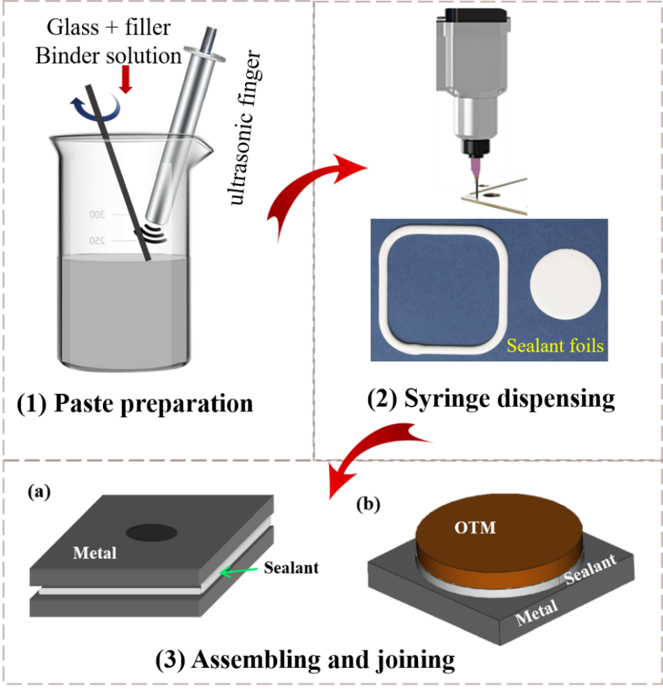
Fig. 1. Schematic illustration of experimental process: (1) glass sealant paste mixing using a stirring rod and ultrasonic finger, (2) sealant foils prepared using the syringe dispensing method, (3) sealant foils assembled in (a) a gas-tightness setup and (b) a simulated membrane stack, followed by a joining process in the furnace
3. Results and discussion

3.1 Glass H

3.1.1 Thermal stability
Fig. 2 shows the DSC plot of glass matrix H at a heating rate of 15 °C/min. The glass transition temperature (T_{g}) of glass H is at 621 °C. An intense exothermal peak between 735 °C (T_{r}) and 764 °C (T_{p}) can be seen, which is related to the precipitation of crystalline phases. The onset melting temperature (T_{m}) is around 968 °C. However, there is no significant melting endothermic peak (T_{mp}) in the testing temperature range up to 1300 °C. The glass-forming tendency and the thermal stability against crystallization on heating this glass was estimated using the Hruby’s methods [36] and DSC data. The parameter K_{gl} of glass H was calculated to be 0.49 according to the equation (e.1). K_{gl} = 0.5 means that glass can be easily prepared simply by free cooling of the melt in air [36]. The higher is the value of K_{gl} for a certain glass, which means that the higher is its glass forming tendency and thermal stability against crystallization [39, 40]. This indicates that the glass H has a good glass-forming tendency and great stability against crystallization.
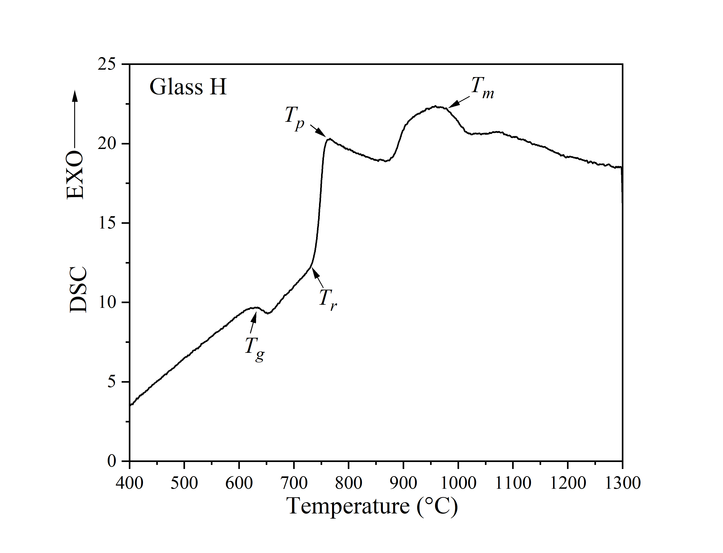
Fig. 2. (a) DSC plot of glass H at a heating rate of 15 °C/min

3.1.2 Thermal expansion behavior
The thermal expansion behaviors of the sintered rod glass H and the glass H specimen annealed for 1000 h at 800 °C are shown in Fig. 3, which is also comparing with the CTE plot of STF25 membrane. According to the results, a noticeable glass transition temperature is not only in the dilatometer curve of as-sintered glass H but also shown in the dilatometer curve after annealing. The glass transition temperature obtained from dilatometer plots coincides with the value from the DSC result. The results indicate that the residual glass phase still exists after long-term aging for glass H. Fig. 4 presents microstructures of dilatometer samples for glass H and annealed glass H after dilatometric measurement (up to 910 °C). Some crystalline phases are formed and the residual glass phase is present in large amount in the as-sintered sample of glass H. In contrast, after 1000 hours of annealing, a significant quantity of the glass phase was consumed as crystalline phases developing and crystal number increasing. This indicates that a small amount of the residual glass phase is left, some of which is located at the grain boundaries in the highly crystallized glass sealant, which also verifies that glass H possessed an excellent thermal stability. The presence of residual glass is crucial for ensuring that the seal is suitable in terms of viscosity, rigidity, and appropriate gas-tightness during high-temperature applications, such as OTM. The dilatometric softening temperature (T_{s}) of glass H is above 900 °C, which is in agreement with the literature [20]. The thermal expansion coefficient of glass H is 8.5–10.8 × 10⁻⁶ /K (200–900 °C). The CTE value of the annealed samples decreased compared to the as sintered glass H. After annealing, the sample has a CTE of 8.0–9.6 × 10⁻⁶ /K (200–900 °C). Both are slightly lower than the desired CTE (12 × 10⁻⁶ /K) of OTM components, i.e. STF25 and Aluchrom. Thus, a strategy needs to be derived to release thermal stresses caused by CTE mismatch, if glass H is used as a sealant for the OTM module. In the next chapter (3.2), the glass H sealants reinforced by ceramic filler Sr₂SiO₄ are discussed in detail.
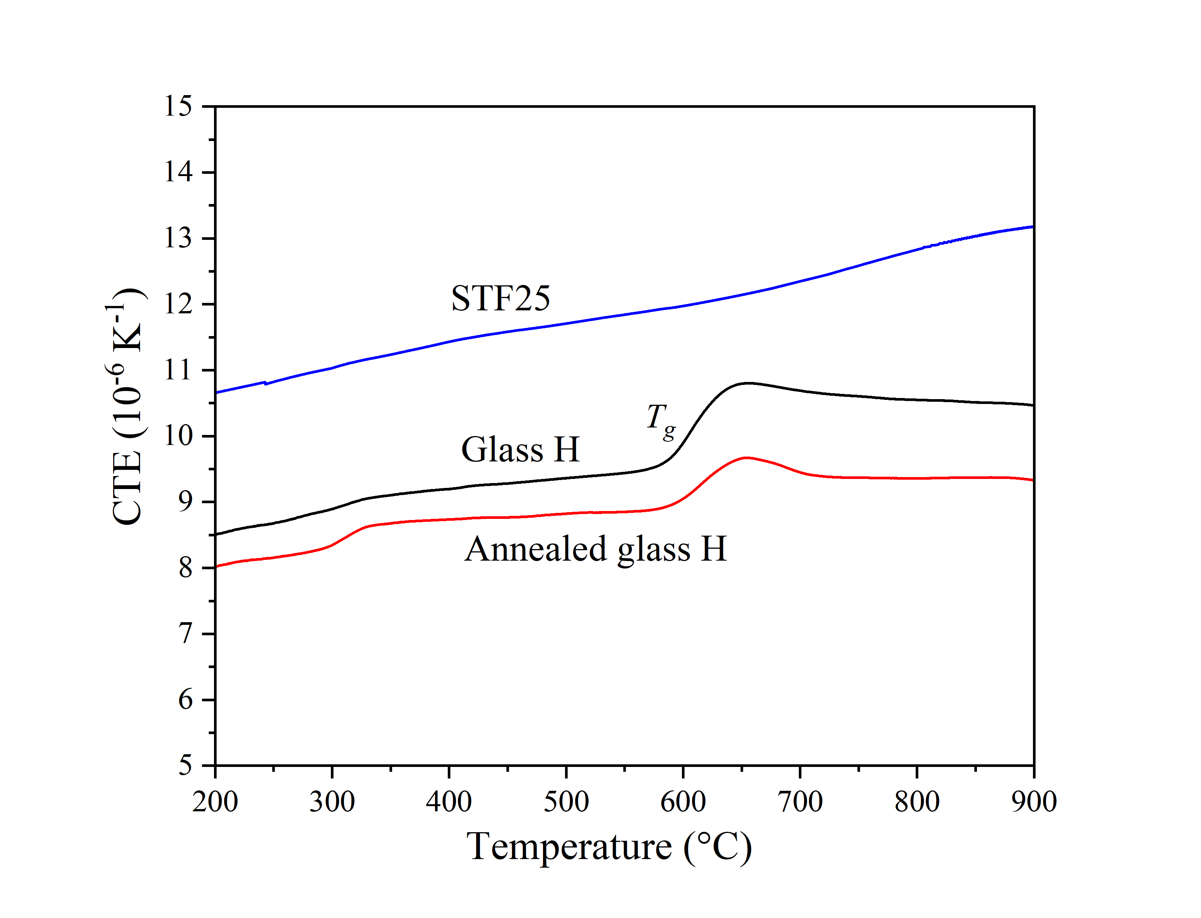
Fig. 3. Dilatometer plots of STF25, the sintered glass H rod (850 °C, 10 h) and glass H aged sample (850 °C, 10 h + 800 °C, 1000 h)
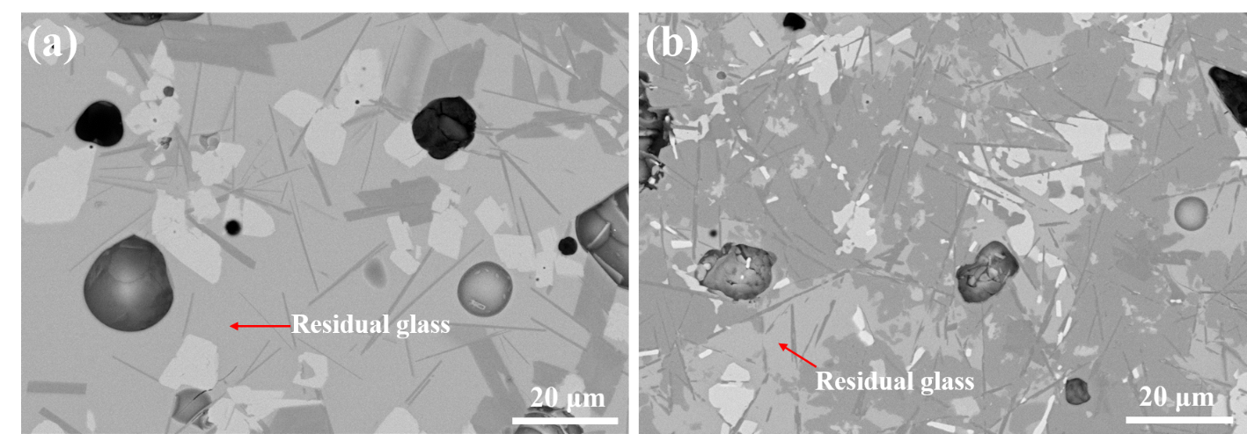
Fig. 4. SEM micrographs of samples after dilatometer measurement (up to 910 °C): (a) glass H sintered at 850 °C for 10 h, (b) the annealed glass H sample sintered at 850 °C for 10 h and subsequently aged at 800 °C for 1000 h.

3.1.3 Crystal structure analyses
To investigate the crystalline phases formed in glass H and their potential influence on thermal expansion properties, XRD analyses were performed for different heat-treated samples supported by the simulation of thermodynamically stable phases using FactSage.
Fig. 5 shows XRD patterns of the annealed glass H samples for five different heat-treatment processes: (a) 764 °C (T_{p}) for 20 h, (b) 800 °C for 20 h, (c) 850 °C for 10 h, (d) 920 °C for 20 h, and (e) 850 °C for 10 h plus 800 °C for 1000 h. Table 3 lists the quantified XRD results using Rietveld refinement. XRD analyses show a typical amorphous peak with a broad diffuse hump in all short-term (10–20 h) annealed samples. The only crystalline phase precipitated after heating at the crystallization peak temperature (T_{p}) 764 °C for 20 h is barium silicate (Ba₅Si₈O₂₁), as seen in Fig. 5 (a). At 800 °C and above additionally hexagonal barium aluminosilicate phase BaAl₂Si₂O₈ (also called hexacelsian, high temperature phase) is present (Fig. 5 b–d). The amorphous fraction of these samples remains high, i.e. 93–98 wt.% (Table 3). It is worth noting, that the XRD method analyzes the crystallographic structure of existing phases only, but not their chemical composition. This means that some elements are likely to be partially substituted by other elements fitting into the crystal structure.
After long term annealing (i.e. 1000 h), the sample is highly crystalline, as seen in Fig. 5 (e). The residual glass phase amount is reduced dramatically to 7.1 wt.%, which is in good agreement with the SEM result (Fig. 4 b). XRD analyses of long-term annealed samples reveal the presence of gehlenite phase Ca₂Al₂SiO₇, bariumzincsilicate BaZnSiO₄ and Itsiite phase Ba₂CaB₂Si₄O₁₄, in addition to the remaining phases of barium silicate Ba₅Si₈O₂₁ and hexacelsian BaAl₂Si₂O₈. The refinement results suggest that the major phases formed from glass H are Ba₅Si₈O₂₁ and Itsiite, which provides a useful information for the further application of glass sealant in long term operation.
Itsiite, Ba₂CaB₂Si₄O₁₄, is a mineral phase newly discovered by Kampf and Joy in 2014 [41]. This phase was confirmed subsequently after crystallization of a similar glass composition [24]. The formation of major phase Itsiite Ba₂CaB₂Si₄O₁₄ in glass H is beneficial for reducing the volatility of boron and exhibits potential self-healing mechanisms according to [42, 43]. This leads to a great improvement in the thermal stability of the resulting glass-ceramic sealant. However, there is lack of investigation for the thermal expansion behavior of Itsiite up to now.
The CTE of other phases detected by XRD, namely barium silicate Ba₅Si₈O₂₁, hexacelsian BaAl₂Si₂O₈, calcium aluminosilicate Ca₂Al₂SiO₇ and barium zinc silicate BaZnSiO₄, are about 14.5 × 10⁻⁶ /K [44], 7.5 × 10⁻⁶ /K [45], 7.9 × 10⁻⁶ /K [46], and 10.4 × 10⁻⁶ /K [47], respectively. Barium silicates are desirable phases in the crystallized glass H based sealant due to their comparably high CTE value. However, low CTE phases, hexacelsian BaAl₂Si₂O₈ and calcium aluminosilicate Ca₂Al₂SiO₇, are also formed in glass H, which is the main reason that CTE values of the aged glass H sample decreased after annealing for 1000 h. The Al₂O₃ concentration in the glass composition should not be too high, as the formation of unfavorable phases, such as BaAl₂Si₂O₈ and Ca₂Al₂SiO₇, is possible under OTM operating conditions. All of the studied barium silicates [44] exhibit CTEs in a range that is suitable for components of sealing materials in high temperature oxygen transport membranes, which could provide an additional idea for designing the optimum glass-ceramic sealants for OTM application.
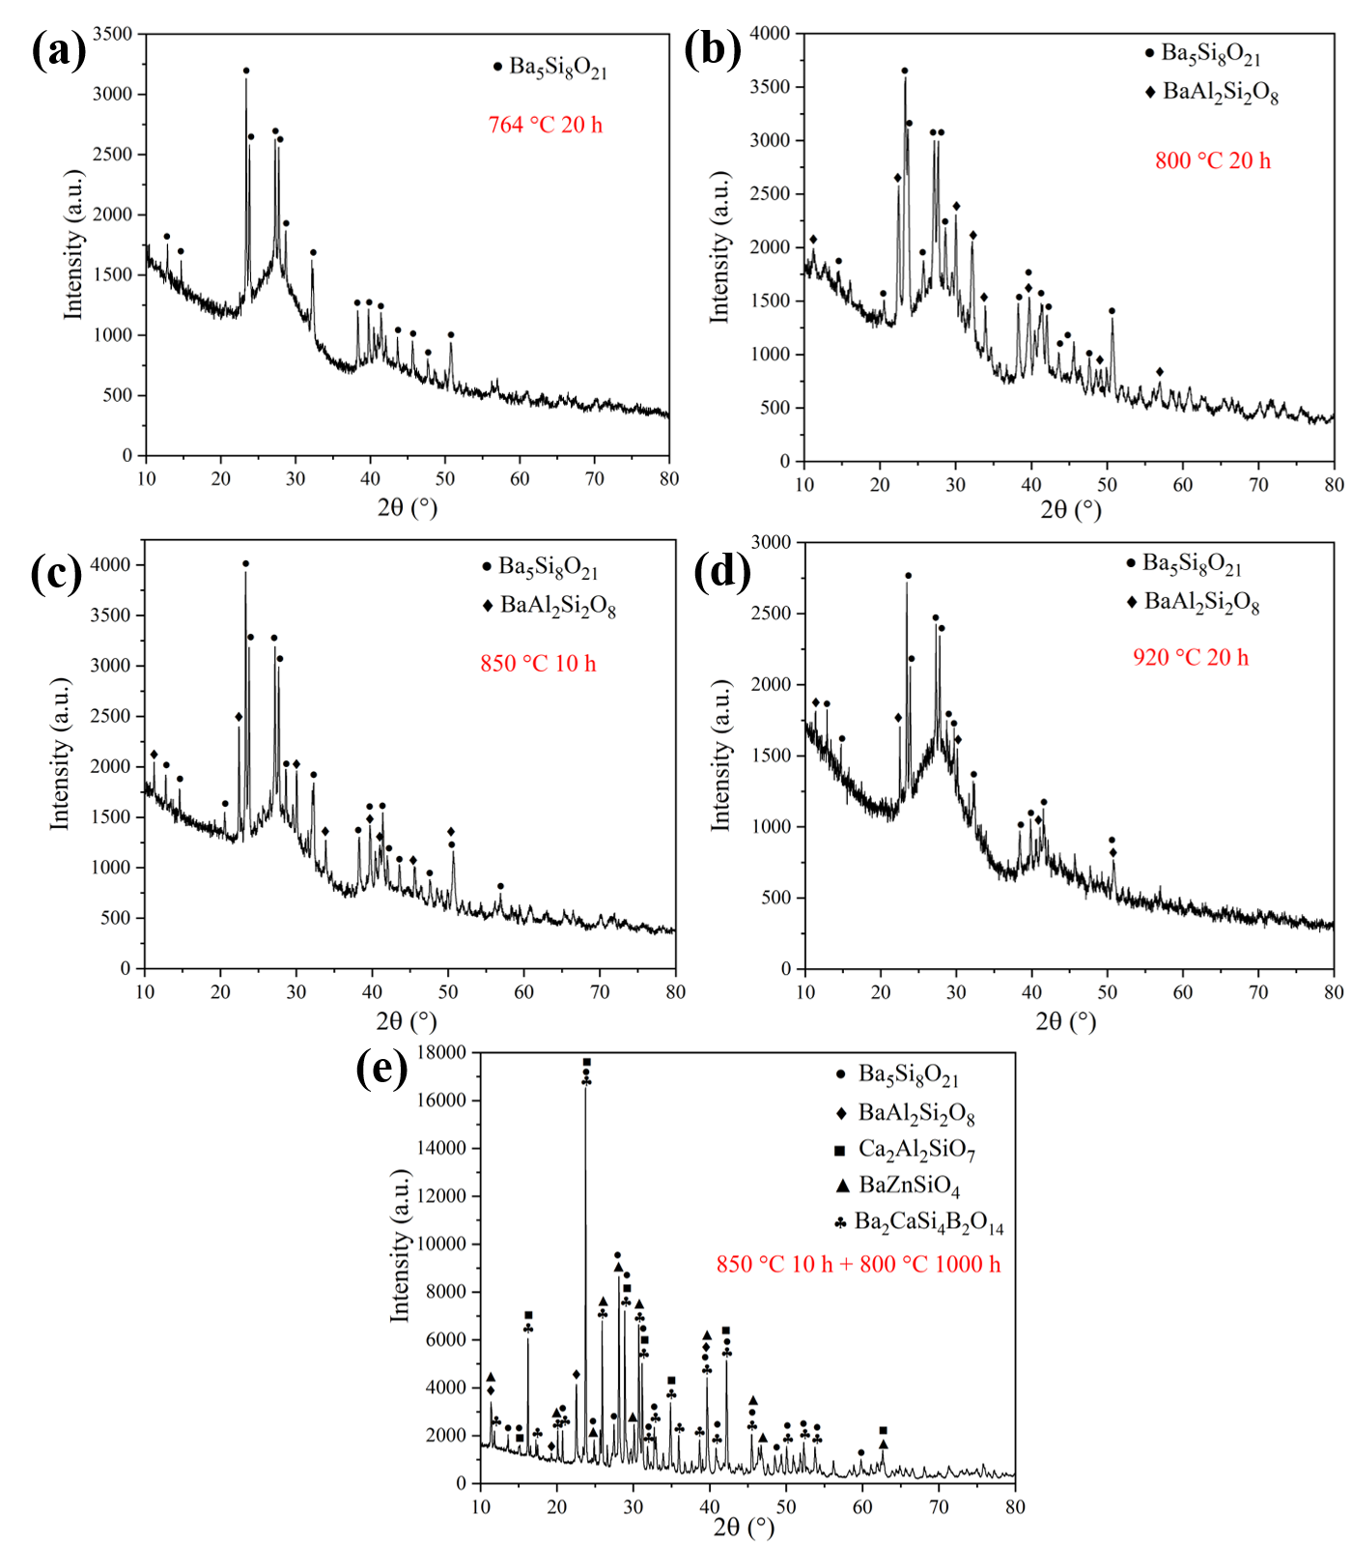 Fig. 5. Glass H after different heat-treatments for crystallization analysis: (a) XRD pattern of glass H after heating at 764 °C for 20 h, (b) XRD pattern of glass H after heating at 800 °C for 20 h, (c) XRD pattern of glass H after heating at 850 °C for 10 h, (d) XRD pattern of glass H after heating at 920 °C for 20 h, (e) XRD pattern of glass H after heat-treatment under 850 °C for 10 h plus 800 °C for 1000 h, with same heating and cooling rate (2 °C/min).

Table 3. Quantification of XRD results using Rietveld refinement
Samples | wt.%  Ba₅Si₈O₂₁ | wt.%  BaAl₂Si₂O₈ | wt.%  Ca₂Al₂SiO₇ | wt.%  BaZnSiO₄ | wt.%  Ba₂CaSi₄B₂O₁₄ | wt.%  Amorphous
764 °C 20 h | 2.3 | - | - | - | - | 97.7
800 °C 20 h | 5.2 | 1.7 | - | - | - | 93.1
850 °C 10 h | 3.1 | 0.8 | - | - | - | 96.1
920 °C 20 h | 1.7 | 0.4 | - | - | - | 97.9
850 °C 10 h + 800 °C 1000 h | 37 | 10.1 | 16.0 | 4.4 | 25.4 | 7.1

Thermodynamically stable phases were calculated considering all possible reactions and phase equilibria using FactSage 8.1 (database FToxid for condensed phases and FactPS for the gas phase) dependent on T at a constant pressure of 1 bar. Gibbs energy is minimized in the system. The chemical composition of glass H given in Table 1 was used as an input for the calculations. Gas does not affect the equilibrium results as no stable gas phase was found below 1300 °C from the calculation. Figure 6 shows the amount of the stable phases with respect to temperature for the composition of glass H. The oxide liquid phase (slag) is calculated to form two separate liquids with different compositions (immiscibility gap). These phases are called Slag#1 and Slag#2. No slag phase separation was observed below 880 °C. Slag#2 shows a minor amount less than 1.8 wt.% (1.8 mol%) in glass H. Ba₅Si₈O₂₁ (CTE: 14.5 × 10⁻⁶ /K [48]) is the major phase from the onset of crystallization, which is in agreement with XRD analysis. Ba₂Si₃O₈ (CTE: 13.2 × 10⁻⁶ /K [48]) is possibly precipitated when heat treatment is above 890 °C, which shows a low fraction of less than 7.8 wt.% (1.4 mol%). The presence of BaSi₂O₅ (12.9 × 10⁻⁶ /K [48]) was predicted below 740 °C (around T_{r}) with a small amount at equilibrium state without taking the formation time into consideration. The FactSage calculations predict the existence of boron-containing Ba₂CaB₆O₁₂ below 890 °C. At higher temperature, the majority of boron is dissolved in the slag phases and the gas phase amount is negligible in calculations. However, this phase does not fit with the XRD results. In contrast, Itsiite Ba₂CaSi₄B₂O₁₄ is identified after long-term annealing, which is not yet included in the database FToxid. Feld#1 means feldspar phase BaAl₂Si₂O₈ (7.5 × 10⁻⁶ /K [45]), which has a fraction of less than 11 wt.% (2.6 mol%) formed below 800 °C according to the FactSage simulation. WOLLA refers to wollastonite which is the solid solution mainly based on CaSiO₃ (CTE: 11.2 × 10⁻⁶ /K[49]). The mole fraction of wollastonite is calculated to be less than 7.1 wt.% (5.5 mol%). Mel-A is the abbreviation of melilite solution (Ca, Ba)₂(Zn, Al, B)(Al, B, Si)₂O₇, which is supposed to consist of Ca₂ZnSi₂O₇ (CTE: 10.4 × 10⁻⁶ /K [49]) in the FactSage calculation, up to 6.3 wt.% (1.8 mol%). The Melilite-A phase was predicted to be stable at 770-830 °C. Ca₂Al₂SiO₇ is formed in glass H according to XRD detections. However, according to present calculations, this compound could not be found directly in the Mel-A phase by calculation due to the possible incompleteness of the model for melilite phase. A low amount of Zn₂SiO₄ (CTE: 2.8 × 10⁻⁶ /K [49]) is present, ≤ 5.3 wt.% (2.1 mol%), from beginning of the crystallization temperature to 1120 °C. Whereas, the BaZnSiO₄ compound cannot be found by FactSage calculations compared with XRD results, since the BaO–ZnO–SiO₂ system is not available in the FToxid database. Two calcium vanadates were predicted and amount to less than 0.5 mol% (V₂O₅ addition amount). Ca₂V₂O₇ converts to Ca₃V₂O₈ phase around 770 °C. However, due to the accuracy limitations, XRD did not detect any vanadate phase in the heat-treated samples.
In summary, the XRD results can be supported by FactSage calculations. Three main phases (Ba₅Si₈O₂₁, BaAl₂Si₂O₈ and Ca₂Al₂SiO₇) detected by XRD were accurately predicted by FactSage. Moreover, the crystalline behavior trend of glass H versus temperature was predicted. Boron-containing phases formed in glass H. Boron is dissolved in the slag and crystal phases, and the amount of gas is negligible by calculations. FactSage simulations can provide a visual guidance for the development of new glass sealants, reduce the level of uncertainty of the experiment and also provide useful information for further studies seeking to improve Glass H properties.
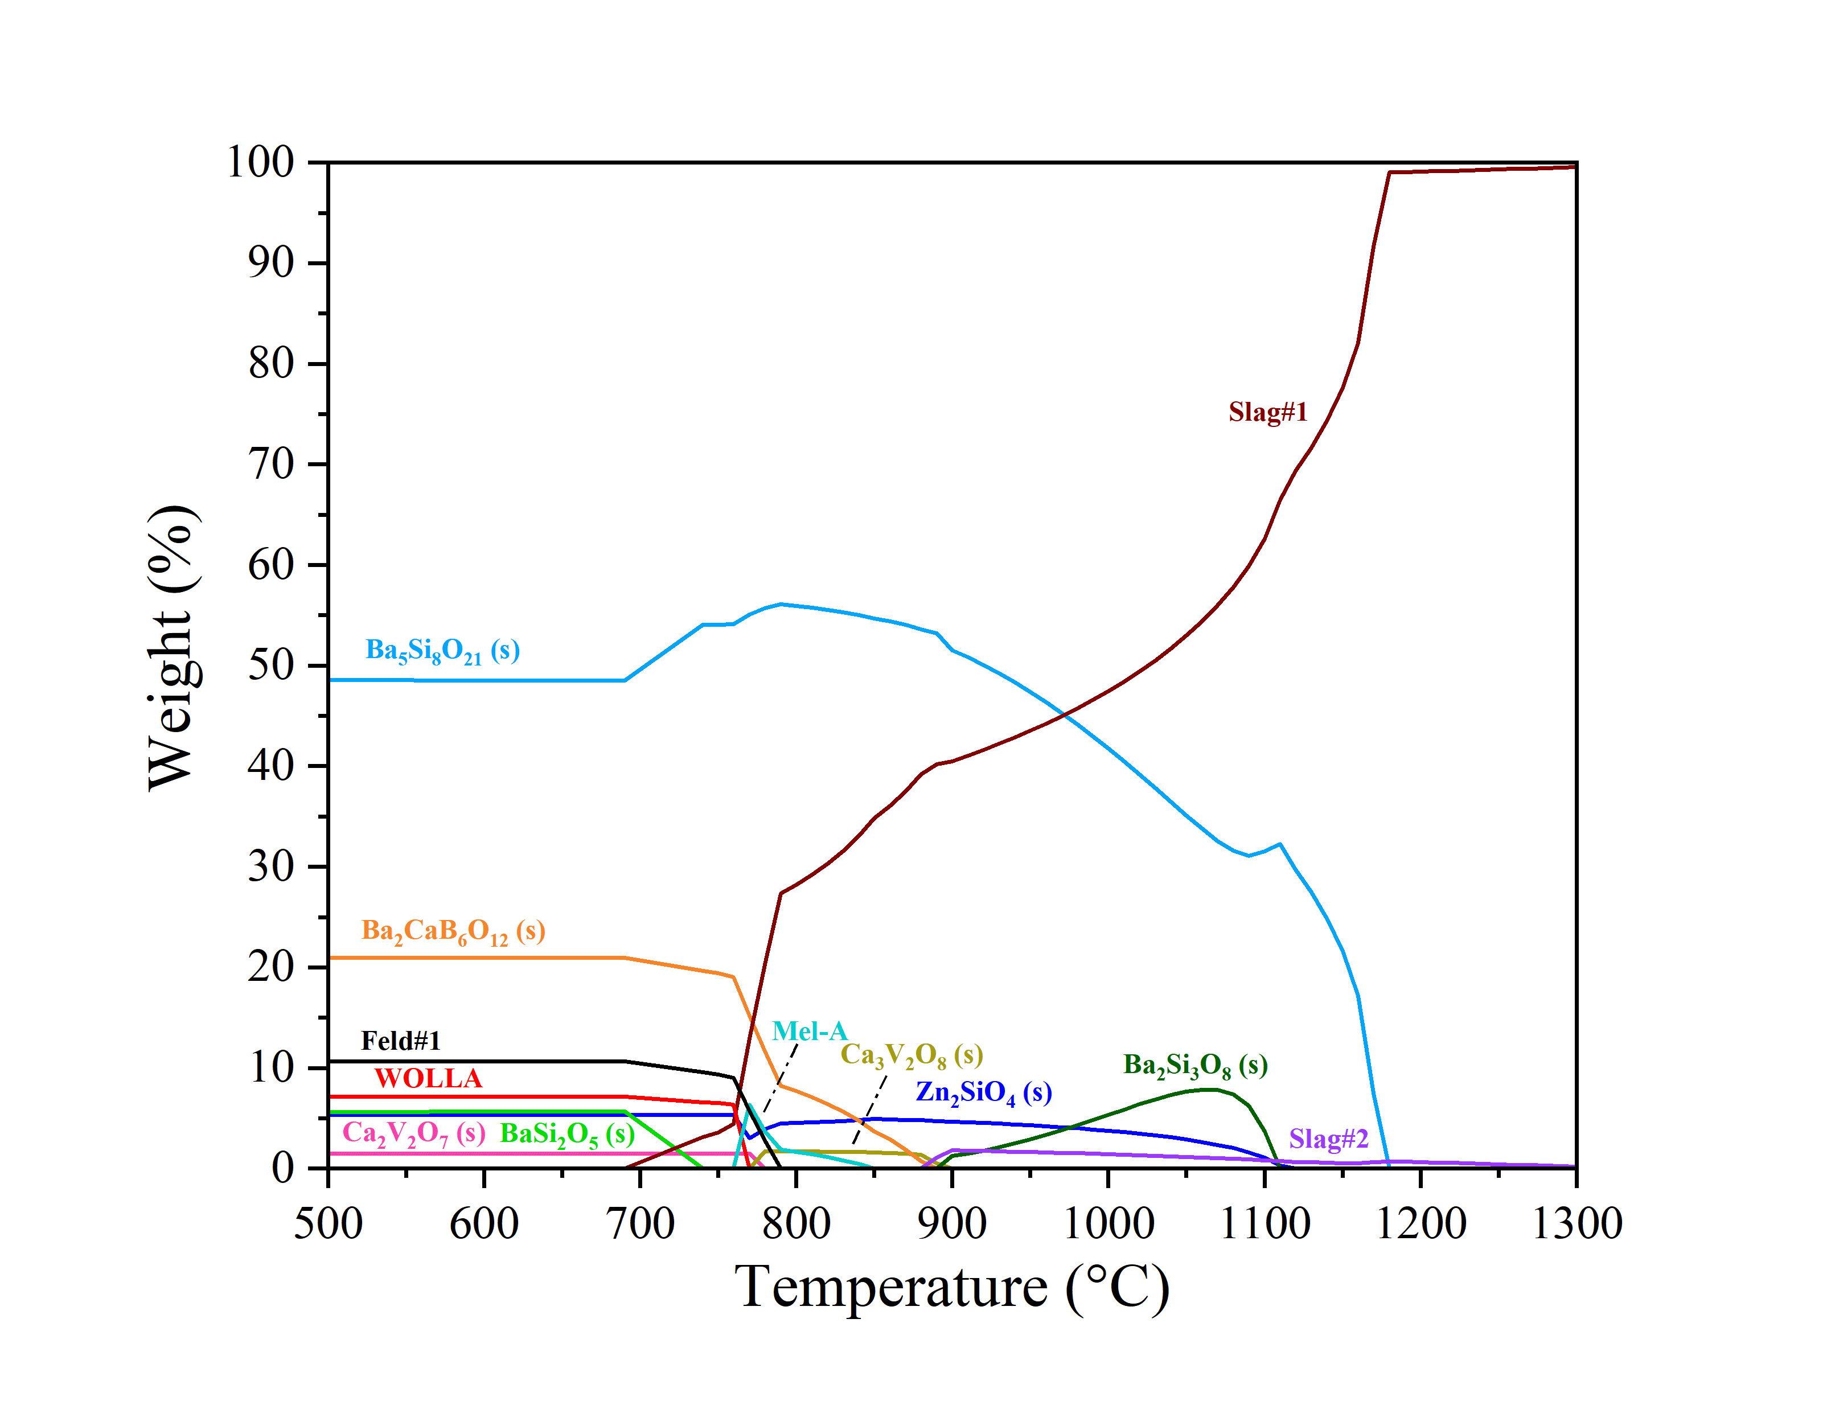
Fig.6. Stable phases versus temperature according to FactSage simulation for glass H

3.2 Sr₂SiO₄ reinforced glass composites

3.2.1 Sr₂SiO₄ synthesis
Fig. 7 shows the XRD-pattern of strontium silicate Sr₂SiO₄ filler powder synthesized at 1350 °C for 30 h. One can see that Sr₂SiO₄ has been identified to exist in the allotropy phases with different symmetries monoclinic and orthorhombic. Residues form quartz (sea sand) and SrCO₃ were not detected. Strontium silicate Sr₂SiO₄ filler was obtained as the anticipated reaction (e.2).
$2SrCO_{3}+\underset{ t=30 h}{SiO_{2}\underset{→}{T=1350 ˚C}}Sr_{2}SiO_{4}+2CO_{2}↑$ (e.2)
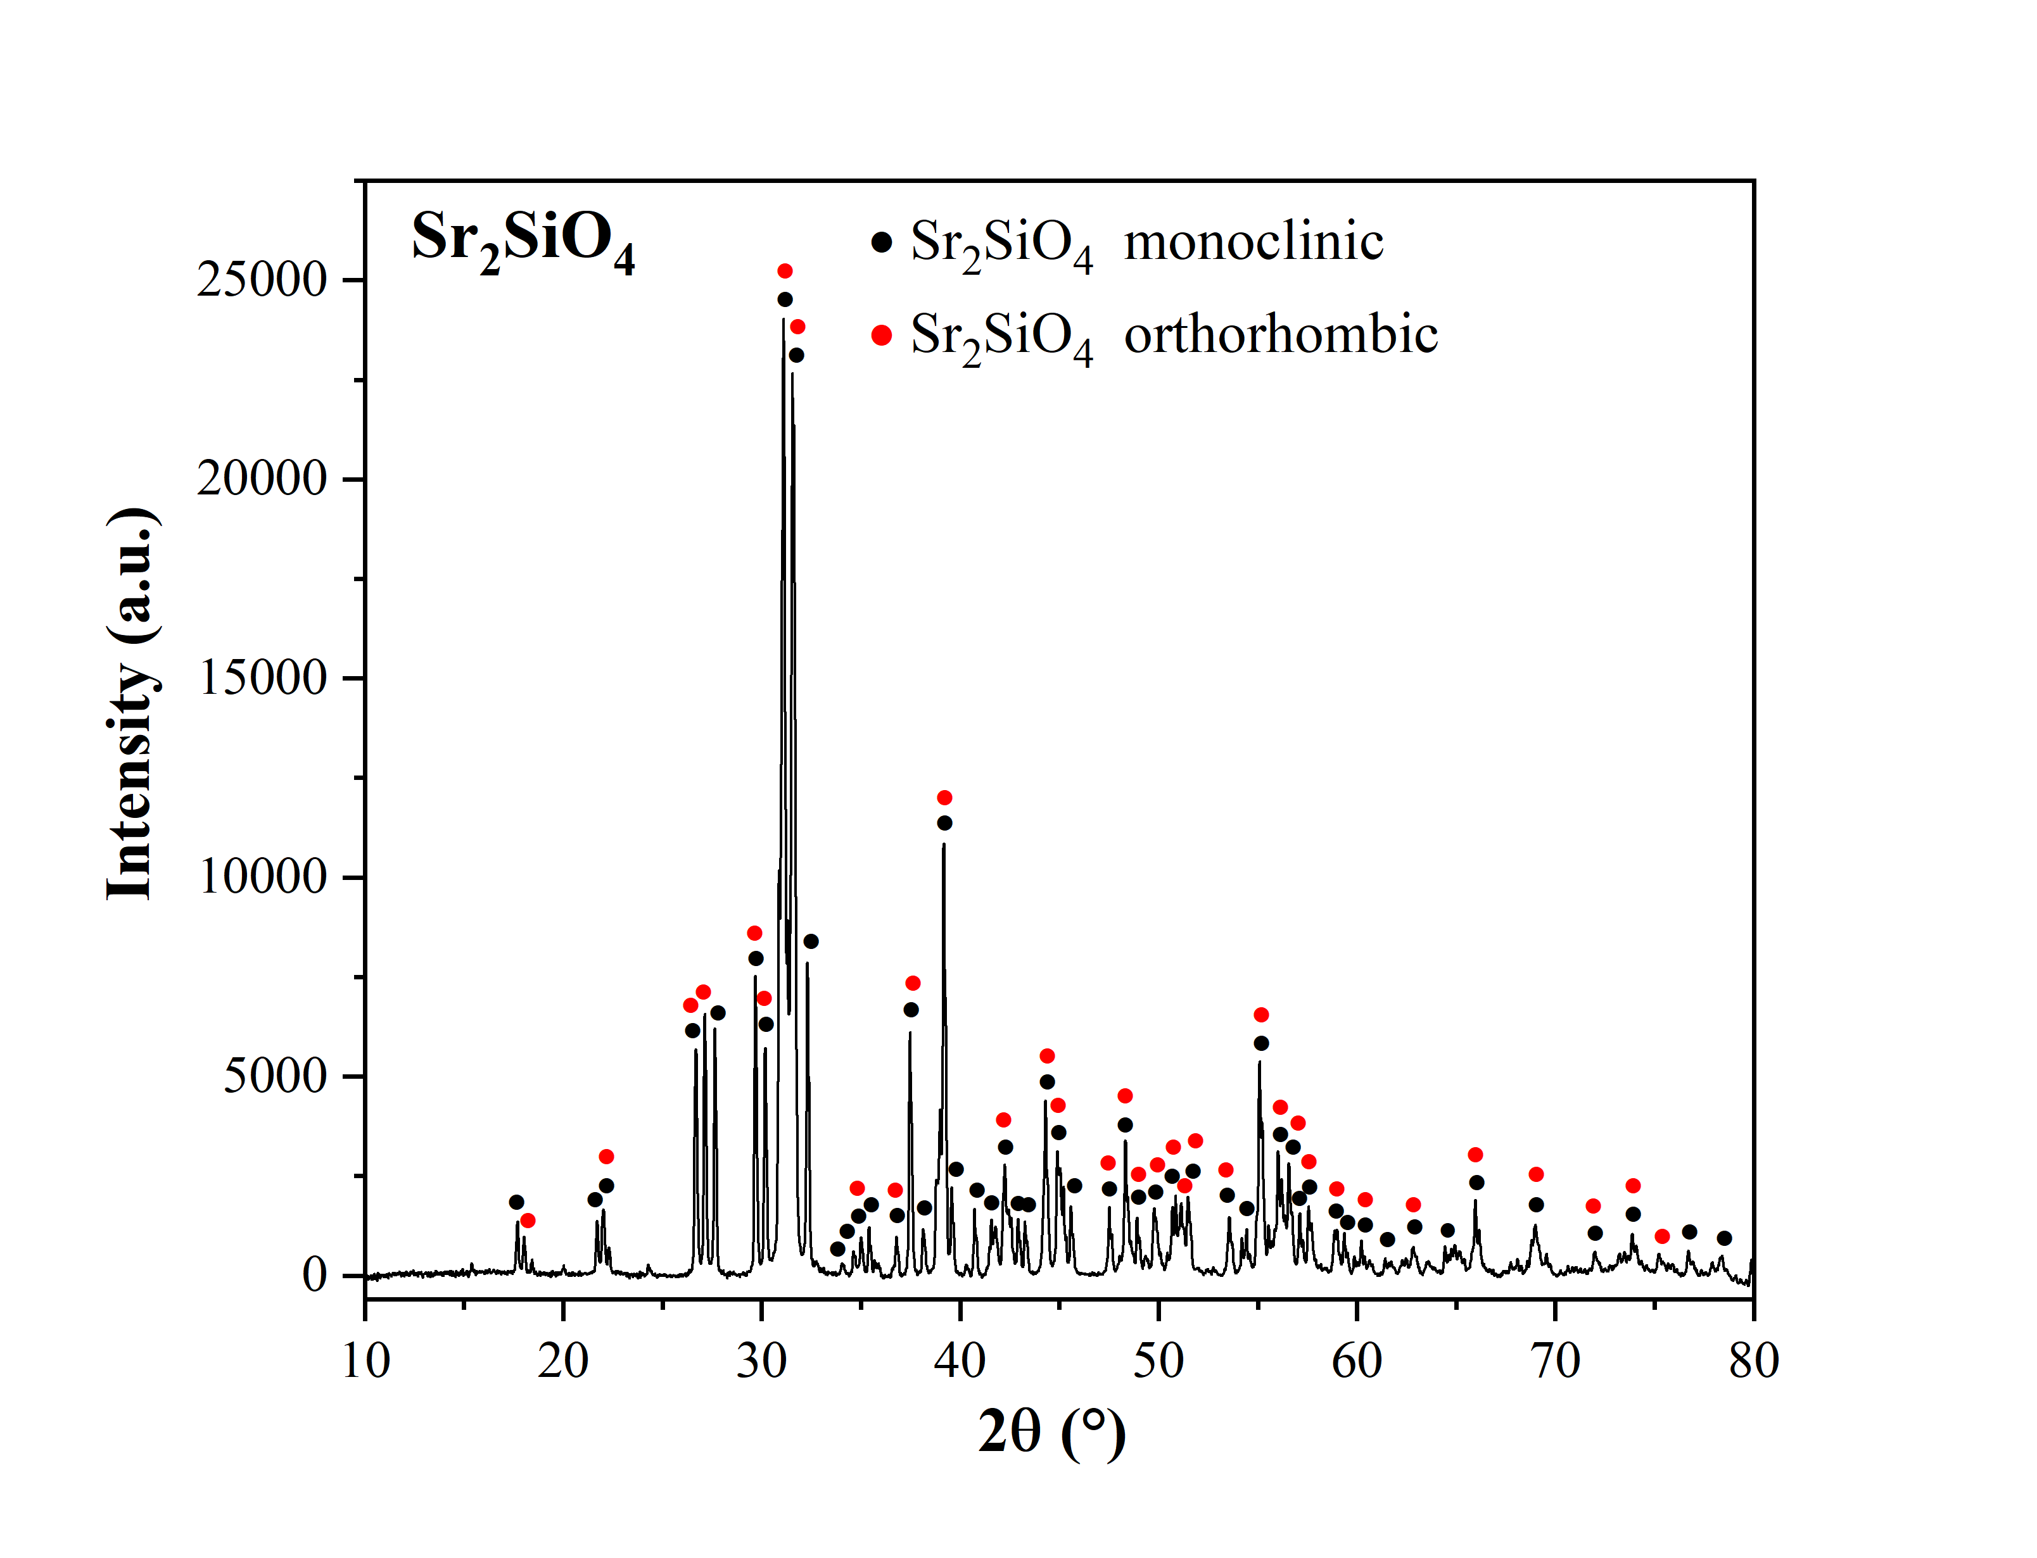
Fig. 7. XRD pattern of the synthesized Sr₂SiO₄ filler (1350 °C for 30 h)

3.2.2 Thermal expansion
Dilatometer measurements were performed for the glass ceramic composites, HS2S10, HS2S20, HS2S30, and HS2S40. The dilatometer bars of the composites were pressed and then sintered at 850 °C for 10 h. Half of the bars were additionally heated at 800 °C for 1000 h annealing. The thermal dilatometric results of the sintered and annealed composites are shown in Fig. 8. The CTE curves of the sintered composites with Sr₂SiO₄ fillers (Fig. 8 a) exhibited a transformation temperature (T_{g}) of around 625 °C which coincides with the DSC results measured for pure glass H. The sintered samples with added Sr₂SiO₄ achieved higher CTE values than pure glass H (see Table 3). The CTE value of the annealed samples decreased compared to the as-sintered composites shown in Fig. 8 (b). The formation of the low CTE phases hexacelsian BaAl₂Si₂O₈ and calcium aluminosilicate Ca₂Al₂SiO₇ in glass H matrix after annealing is the main reason for the decline of CTE values, from SEM, XRD results and the FactSage simulation in 3.1 part. CTE values improved with the filler material amount increased. The addition of 20 wt.% Sr₂SiO₄ resulted in the highest CTE values of up to 11.7 × 10⁻⁶ /K for the as-sintered sample, while the addition of 40 wt.% Sr₂SiO₄ achieved the highest CTE up to 10.9 × 10⁻⁶ /K after annealing, respectively, as measured in a temperature range between 200 °C and 900 °C (see Table 3).
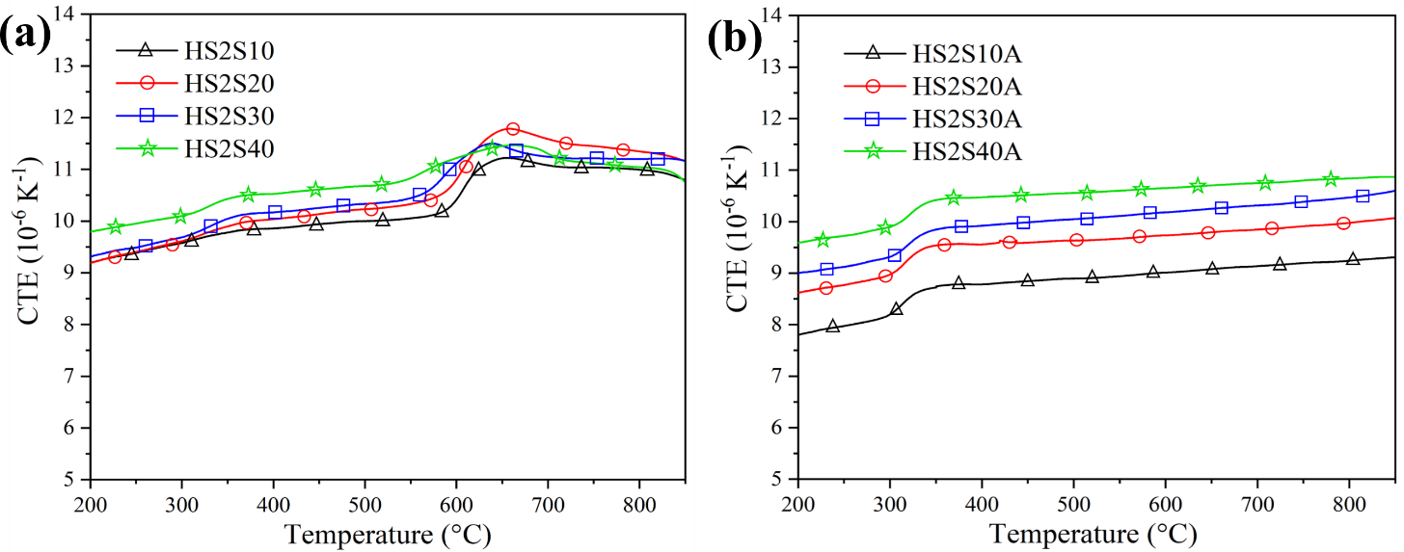
Fig. 8. CTE curves for (a) sintered and (b) annealed composites samples
Table 3. Coefficients of Thermal expansion (as-sintered and long-term annealed) of glass H and the glass ceramic composite sealants
Sample | CTE [×10⁻⁶ K⁻¹]  (200–900 °C) | Annealed sample | CTE [×10⁻⁶ K⁻¹]  (200–900 °C)
Glass H | 8.5–10.8 | HA | 8.0–9.6
HS2S10 | 9.2–11.2 | HS2S10A | 7.9–9.3
HS2S20 | 9.2–11.7 | HS2S20A | 8.7–10.1
HS2S30 | 9.3–11.5 | HS2S30A | 9.0–10.6
HS2S40 | 9.8–11.5 | HS2S40A | 9.6–10.9

3.2.3 Microstructure of composites
To investigate the microstructural characteristics of glass-based composites with the addition of different amounts of Sr₂SiO₄, SEM analysis was performed on the annealed samples, as shown in Fig. 9. Microstructures of these composites were influenced by the amount of the Sr₂SiO₄ additive. In the case of the composites with the addition of 20–30 wt.% Sr₂SiO₄, a homogeneous, dense structure with closed porosity was observed (Fig. 9 a-c). However, many large irregular pores were found for the composite with the addition of 40 wt.% Sr₂SiO₄. This phenomenon can be explained by the fact that the glass is unable to completely wrap the filler particles during viscous flow sintering if the amount of filler in the composite material is too high (Fig. 9 d). The probability of open pores is increased and fully densified materials can hardly be obtained, which would lead to gas leakage when used in an OTM module. Fig. 10 shows SEM-EDS maps of the HS2S20A sample. The Sr₂SiO₄ filler shows a chrysanthemum-shape morphology. The filler particle is surrounded by needle-like phases which were determined to be BaAl₂Si₂O₈ [24, 29] formed from glass H during heating. This is in an agreement with XRD crystallization analysis and the FactSage simulation of the composition of glass H. The strontium contained in the filler material slightly diffuses into the glass matrix. The best microstructure with respect to homogeneity and density was observed for the composite with the addition of 20 wt.% filler and was chosen as a sealing material for further tests.
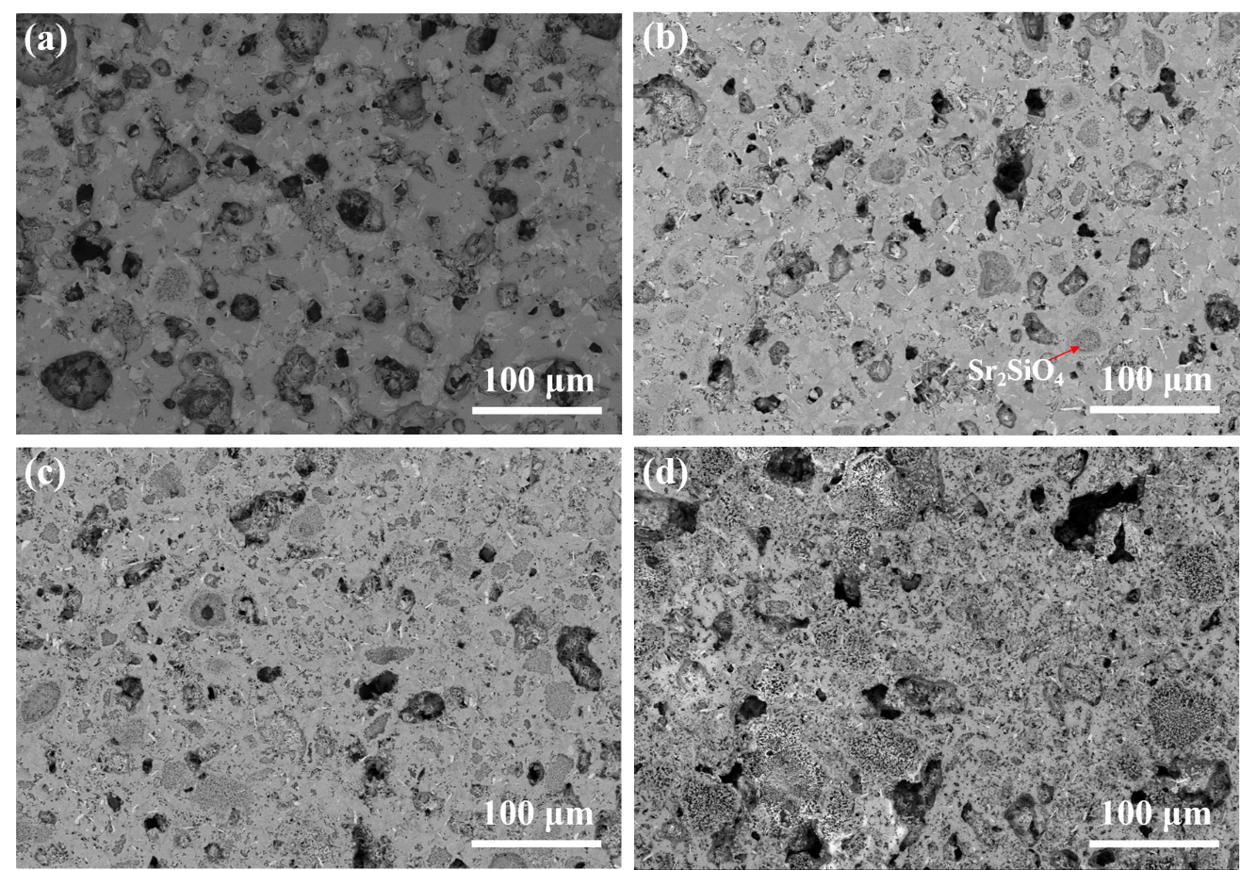
Fig. 9. SEM-EDS analyses of annealed composites (a) HS2S10A, (b) HS2S20A, (c) HS2S30A, and (d) HS2S40A
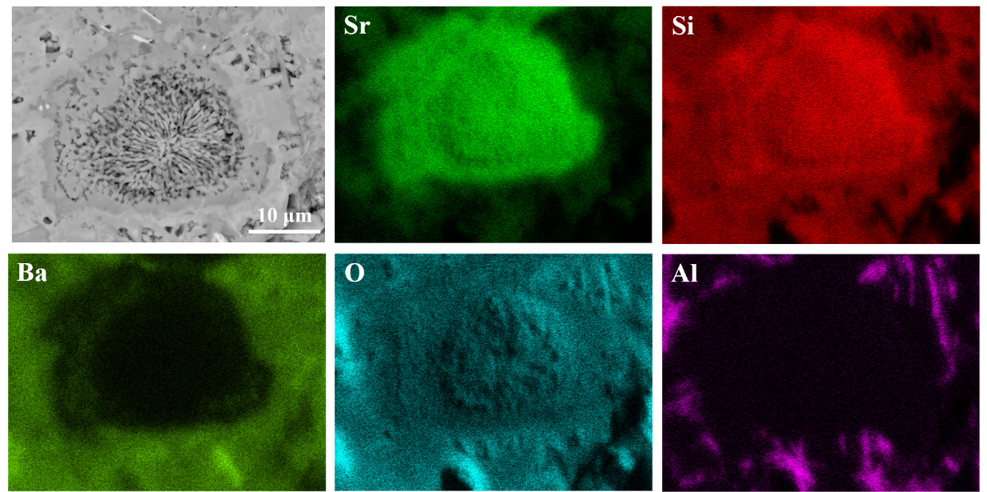
Fig. 10. SEM-EDS maps of a filler particle of the HS2S20A sample using TruMaps

3.2.4 Thermal viscous deformation
The reinforced composite HS2S20 was analyzed by means of HSM to investigate viscous deformation behavior and the optimum temperature for joining OTMs, because of its matchable CTE value with STF25 and dense microstructure. The relative shrinkage of width, height, and area as a function of temperature can be seen in Fig. 11 (a). Fig. 11 (b) displays the shadow images at the fixed viscosity temperature values (T_{FS}, T_{MS}, T_{D}, T_{S}, T_{HB} and T_{F}). From the shrinkage behavior, the optimal joining temperature of the HS2S20 glass-ceramic sealant is assumed to be around the maximum expansion peaks (in height and area variation ratio curves) and sphere temperature (T_{s}) 957 °C, i.e. in a range of 920 °C–960 °C.
The method proposed by Pascual et al. [38] was adopted to predict the viscosity–temperature data of the glass-ceramic sealant HS2S20 based on hot stage microscopy (TOMMIplus). Moreover, the viscosity-temperature data of HS2S20 were compared with the pure glass matrix H [45] as seen in Table 4. At a typical joining temperature of around 850 °C, pure glass H would be at half-ball stage, but with the addition of 20 wt.% Sr₄SiO₄ to the HS2S20 composite, it is just in the deformation range at that temperatures. The addition of ceramic fillers could reduce the creep behavior of the sealant at high temperature. Fig. 12 shows the fitting lines of the two sets of viscosity–temperature data, which could offer the possibility of predicting the viscosity of the glass-based sealants. Moreover, it was clear that the addition of ceramic filler Sr₂SiO₄ caused an increase in viscosity and the fixed viscosity temperatures of the glass sealant.

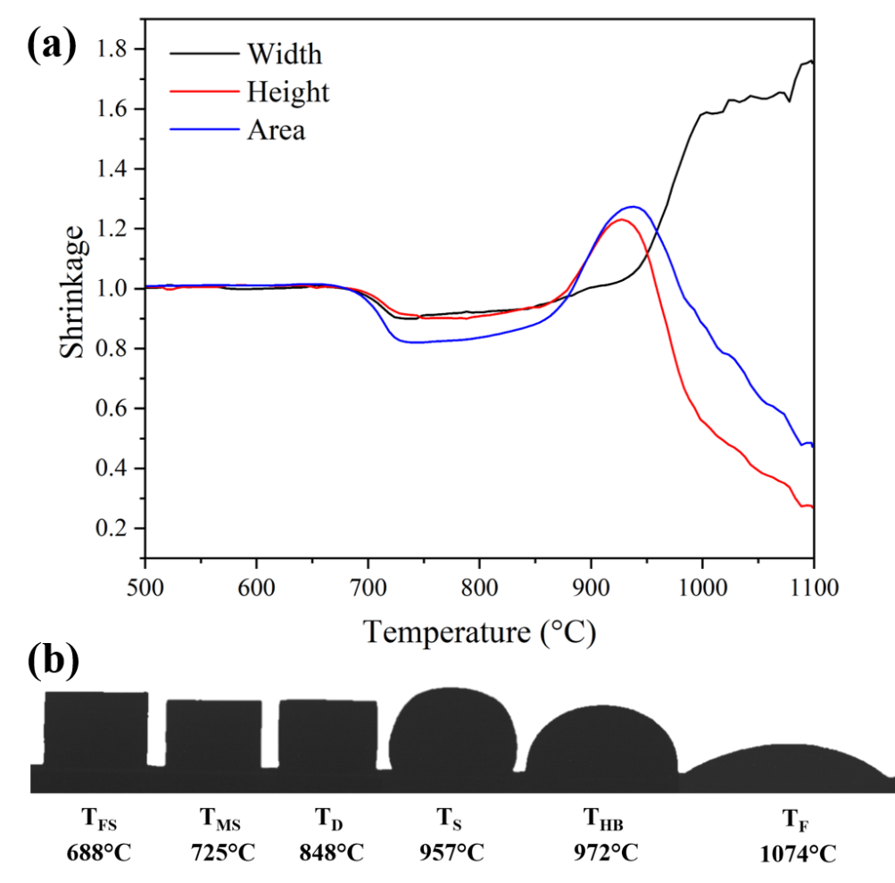
Fig. 11. HSM analysis (TOMMIplus) for HS2S20 glass composite sealant recorded at 5 °C/min: (a) shrinkage curves, (b) shadow images of the sample at the fixed temperature

Table 4. Fixed viscosity temperatures of pure glass H [45] and the glass H reinforced HS2S20 composite
Sample | Fixed viscosity (log η) (η, dPa·s) [38]
 | 9.1 | 7.8 | 6.3 | 5.4 | 4.1 | 3.4
 | Temperature (°C)
 | T_{FS} | T_{MS} | T_{D} | T_{S} | T_{HB} | T_{F}
Glass H [45] | 610 | 725 | 730 | 795 | 844 | -----
HS2S20 | 688 | 728 | 848 | 957 | 972 | 1074

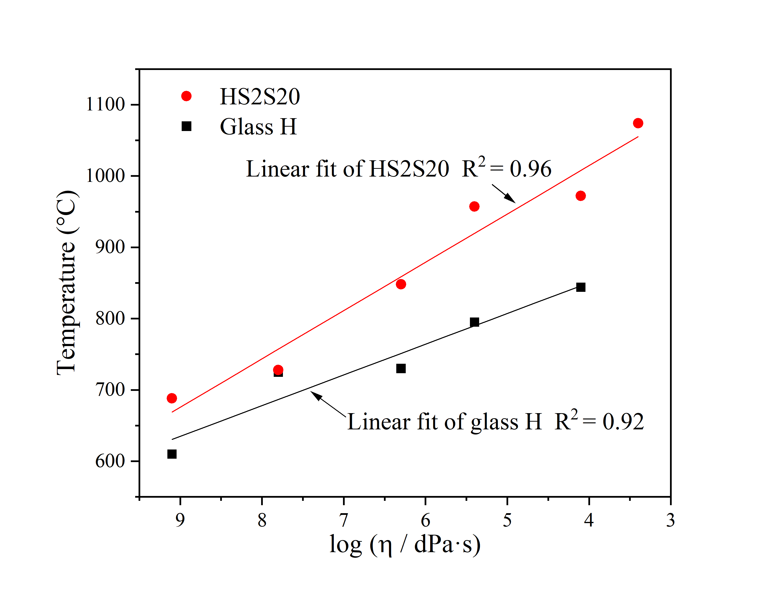
Fig. 12. Viscosity-temperature curves of glass H and HS2S20 composite sealant

3.2.5 Gas-tightness
The gas-tightness results of samples joined under different thermal processes with the HS2S20 glass-ceramic composite are summarized in Table 5. 850 °C is the typical joining temperature for the sealing of the SOFC stack with glass matrix H. Temperature of 920 °C and 960 °C were chosen according to the results of the HSM analysis reported above. The setup joined at 850 °C for 10 h exhibited leakage under a dead load of 800 g and the broken sample showed that the glass-ceramic sealant layer split in the middle. In order to improve the sealing behavior of HS2S20 at 850 °C, the area load of the sample was increased to 1200 g, which achieved good gas-tightness. Joining processes at high temperatures above 850 °C for shorter dwelling time were also investigated. Two symmetrical setups fast jointed at 920 °C and 960 °C with an adequate deadload exhibited helium leakage values that were lower than the detection limit of 10⁻⁹ mbar·l·s⁻¹. This would fulfill the requirements for the high temperature operation of an OTM module [50]. Besides, the hermetic samples sealed with the glass-ceramic sealant HS2S20 under different joining processes all obtained the same joining gap of around 0.3 mm. In the case of the same sealing material, the sealing process is affected by temperature, pressure, and dwell time. And temperature and pressure are key factors for successful sealing. At an elevated temperature, glass sealants generally have better creep properties and good wetting behavior with the counterparts, as can be seen from the HSM profiles in Fig. 9 (b). Therefore, in order to obtain the same sealing result, a longer dwell time and higher dead load were adopted and adjusted for the HS2S20 gas-tightness setup. Microstructural analysis for the joints assembled with STF25 is presented in the next chapter, which is also important for choosing the appropriate thermal treatment for this sealing material.
Table 5. Gas tightness measurements on samples sealed by the HS2S20 sealant under different joining processes
Joining process | Dead load | Gas tightness  mbar·l·s⁻¹ | Joining gap
850 °C, 10 h | 800 g | leakage | ---
850 °C, 10 h | 1200 g | ˂10⁻⁹ | 0.3 mm
920 °C, 15 min | 800 g | ˂10⁻⁹ | 0.3 mm
960 °C, 10 min | 520 g | ˂10⁻⁹ | 0.3 mm

3.2.6 Microstructure of assembled joints
In order to simulate the joining behavior of the sealant in the OTM stack, the HS2S20 sealant was assembled in between a STF25 membrane and an Aluchrom plate, and the joints were heated under different thermal conditions: 960 °C dwell time for 10 min, 920 °C dwell time for 15 min, 850 °C dwell time for 10 h.
Fig.13 presents the microstructures of the STF25/HS2S20/Aluchrom joint, which was joined at 960 °C for 10 min. Some large pores are formed in the sealant, as seen in Fig. 13 (a). The glass matrix exhibits a good viscous flow state at a high temperature of around 960 °C, and at this time, the small pores in the sealant were getting easily in contact to each other to aggregate into large bubbles, some of which may be released under deadload, while others remained in the sealant as closed pores. It can also be seen that some tiny cracks formed in the composite sealant layer where the large pores agglomerated. Since helium leakage showed excellent gas-tightness for the sample sealed at 960 °C, it is assumed that the cracks were formed during metallographic processing, such as cutting and grinding. The filler Sr₂SiO₄ particles were also found in the sealant, as marked in Fig. 13 (b). The ceramic filler powders partially dissolved in the glass matrix at high temperature of 960 °C. The Sr₂SiO₄ filler was surrounded by a halo which was analyzed by EDS and found to be a diffusion layer consisting of Ba/Sr/Ca/Si, as seen by the mapping images in Fig. 14. The dark grey needle-shaped phase in the amorphous matrix is attributed to BaSi₂Al₂O₈, which is in good agreement with the XRD results and FactSage simulations (Fig 5 and 6). The HS2S20 sealant exhibited good adhesion for joining with the module components Aluchrom and STF25 (Fig. 13 c and d). No cracks or delamination were observed at either interface. However, the foam-like porosity has a high risk of leakage and insufficient strength. Further mechanical testing will be carried out to measure the bonding strength of the glass ceramic sealant in our next paper.

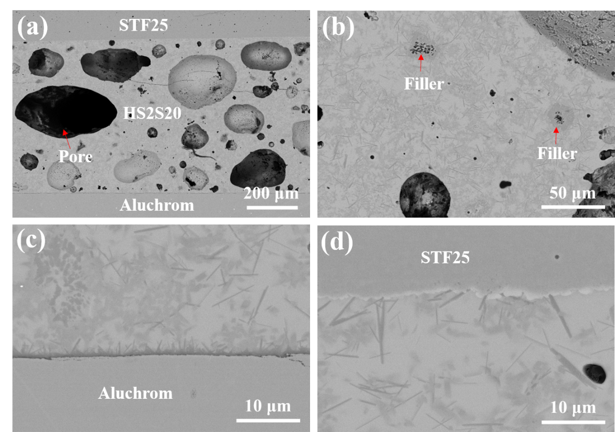
Fig. 13. SEM images of the joint STF25/HS2S20/Aluchrom, joined at 960 °C for 10 min with a dead load of 60 g, (a) the cross-section of the joint, (b) magnification of sealant HS2S20 part, (c) magnification of interface HS2S20/Aluchrom, (d) magnification of interface STF25/ HS2S20
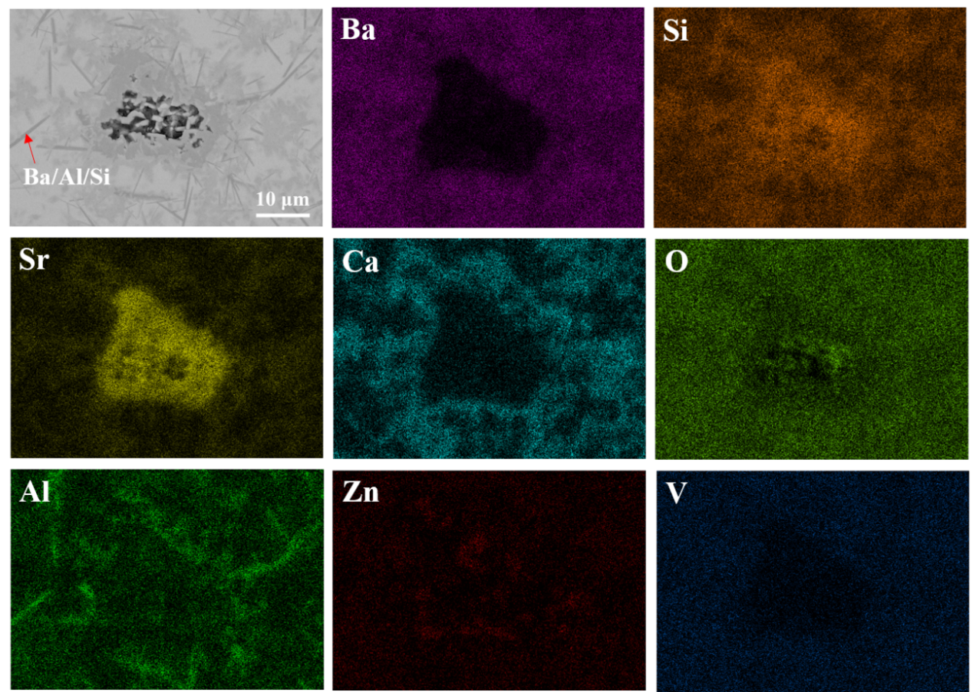
Fig. 14. SEM-EDS TruMaps of the HS2S20 sealant from STF25/HS2S20/Aluchrom joint
Fig. 15 compares the SEM images of the cross sections of the STF25/HS2S20/Aluchrom joints, which were joined under different processes: 920 °C for 15 min (a, b), 850 °C for 10 h (c–e). The HS2S20 sealant joined at 920 °C for 15 min exhibited a highly porous structure compared to the joints heated at 850 °C, as the viscosity and strength of the glass matrix are lower at a high temperature and gas bubbles are easier to expand. The HS2S20 joint that was joined at 920 °C showed a crack-free microstructure and good adhesion to the STF25 membrane and Aluchrom counterpart.
Although the stack joined at 850 °C showed no separation and connected well with both the Aluchrom and OTM before cutting and polishing, clear cracks were found in the sealant. The sealant is the weakest and most fragile part of the whole stack. In addition, the long-term dwell time makes the glass matrix precipitate more crystal phases, which indicates that this joint (850 °C) is more fragile than the short time sintered samples. However, the sealant shows good adhesion with Aluchrom and STF25 at the interfaces joining at 850 °C. In addition, no covered halo was observed around the Sr₂SiO₄ filler in the stack joined at a relatively low temperature of 850 °C.
In those three joints, BaCrO₄ or SrCrO₄ was not observed at the interface of glass ceramic sealant and Aluchrom after joining in this study. Some researchers also reported the disadvantageous formation of BaCrO₄ or SrCrO₄ was limited to regions of the glass ceramic sealant that are directly exposed to air [51]. Further long-term thermal mimicking experiment will be performed in the future to investigate the possibility of actual application of this glass ceramic sealant.
Besides, the microstructures of the glass composite joints are not full densified. Pores may be existed at beginning in glass foil which should be careful to remove bubbles before dispensing or printing. A centrifuge is planning to use in the future to help to deaeration for the glass ceramic paste.
In summary, the joining performance of the HS2S20 sealant joined at a high temperature of 920 °C is the most promising. The sealant joined at 960 °C causes problems related to the agglomeration of pores and a high risk of leakage in further operation. The sealant jointed at 850 °C requires a longer period of time to join Aluchrom and STF25, and also exhibited a higher likelihood of crystalline formation and a fragility risk. The ceramic filler powders are partially solved in the glass matrix at 960 °C and 920 °C, and covered with a halo diffusion layer consisting of Ba/Sr/Ca/Si.

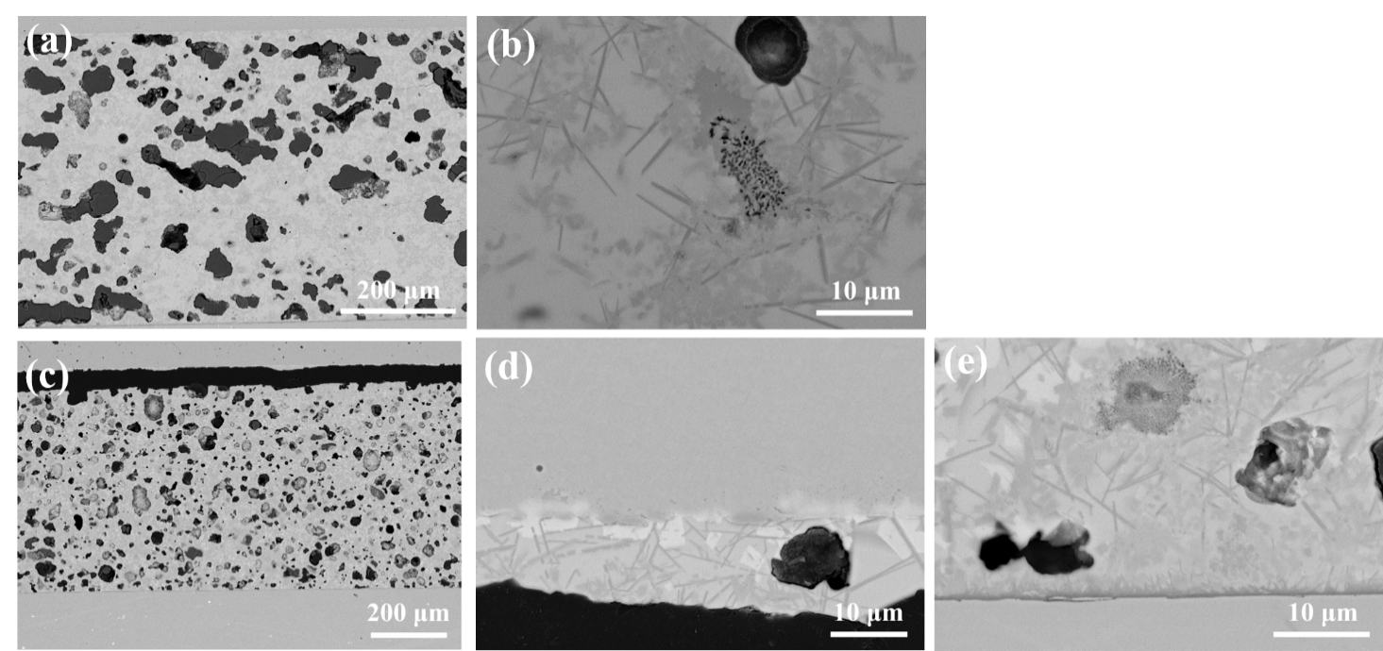Fig. 15. SEM images of the cross-sections of STF25/HS2S20/Aluchrom joints: (a, b) jointed at 920 °C for 15 min with a 100 g dead load, (c-e) jointed at 850 °C for 10 h with a 150 g dead load

4. Conclusion
Glass H exhibits an excellent glass-forming tendency and high thermal stability due to its high K_{gl} value and the existence of residual glass after long term annealing. The CTE of glass H is 8.5–10.8 × 10⁻⁶ /K, which decreased after annealing. XRD results and the FactSage simulation indicate that the formation of the low CTE phases hexacelsian BaAl₂Si₂O₈ and calcium aluminosilicate Ca₂Al₂SiO₇ in glass H after annealing is the main reason for the decline of CTE values. A good agreement was found between the Rietveld refinement of XRD experiments and the FactSage simulation. Three main phases (Ba₅Si₈O₂₁, BaAl₂Si₂O₈ and Ca₂Al₂SiO₇) detected by XRD were accurately predicted by FactSage. Moreover, the FactSage simulations demonstrated that boron is dissolved in the slag and crystal phases, and the amount of B-gas volatilization is negligible below 1300 °C. Thus, crystallization study can provide a good guidance for the development of new glass-ceramic sealants.
Following that, Sr₂SiO₄ was added at 10–40 wt.% to the glass matrix H. The CTE improved with increasing filler content. The addition of 20 wt.% Sr₂SiO₄ achieved the highest CTE value of up to 11.7 × 10⁻⁶ /K for the as-sintered sample, while the addition of 40 wt.% Sr₂SiO₄ produced a CTE of up to 10.9 × 10⁻⁶ /K after annealing. The HS2S20 composite with 20 wt.% Sr₂SiO₄ filler achieved a homogeneous, dense structure. The joining temperature of the HS2S20 glass-ceramic sealant was determined to be around 920–960 °C. The joining behaviors were investigated by comparing three joining temperatures (850 °C, 920 °C, 960 °C). Excellent hermeticity with low helium leakage rates below 10⁻⁹ mbar·l·s⁻¹ was obtained for three symmetrical samples joined at different temperatures with an adequate dead load. Joining temperature and pressure are key factors for successful sealing. Good joining behavior was observed in the STF25/HS2S20/Aluchrom joint that was joined at 920 °C. 920 °C is the best joining temperature for HS2S20 sealant.

Acknowledgment
The authors would like to thank A. Cramer, T. Breuer, D. Federmann, C. Hoven, M. Kappertz and A. Mierau for their technical support as well as D. Naumenko for providing the Aluchrom plates. We are also grateful for the support of the China Scholarship Council in conducing this research.

Declaration of interest statement
The authors declare that they have no conflict of interest.

References
[1] M. Vellini, M. Gambini, CO₂ capture in advanced power plants fed by coal and equipped with OTM, Int. J. Greenh. Gas Control, 36 (2015) 144-152.
[2] W.A. Meulenberg, F. Schulze-Kuppers, W. Deibert, T. Van Gestel, S. Baumann, Ceramic Membranes: Materials - Components - Potential Applications, Chem. Ing. Tech., 91 (2019) 1091-1100.
[3] K. Zhang, J. Sunarso, Z.P. Shao, W. Zhou, C.H. Sun, S.B. Wang, S.M. Liu, Research progress and materials selection guidelines on mixed conducting perovskite-type ceramic membranes for oxygen production, RSC Adv., 1 (2011) 1661-1676.
[4] A.A. Murashkina, E.Y. Pikalova, A.K. Demin, Promising membrane materials based on strontium titanate, Russian Journal of Electrochemistry, 45 (2009) 542-547.
[5] R.O. Silva, J. Malzbender, F. Schulze-Kuppers, S. Baumann, M. Kruger, O. Guillon, Microstructure and anisotropic mechanical properties of freeze dried SrTi_{0.75}Fe_{0.25}O_{3-δ} for oxygen transport membrane substrates, J. Eur. Ceram. Soc., 38 (2018) 2774-2783.
[6] R.O. Silva, J. Malzbender, F. Schulze-Kuppers, S. Baumann, M. Kruger, O. Guillon, Creep behaviour of dense and porous SrTi_{0.75}Fe_{0.25}O_{3-δ} for oxygen transport membranes and substrates, J. Eur. Ceram. Soc., 38 (2018) 5067-5073.
[7] Y. Liu, V. Motalov, S. Baumann, D. Sergeev, M. Muller, Y.J. Sohn, O. Guillon, Thermochemical stability of Fe- and co-functionalized perovskite-type SrTiO₃ oxygen transport membrane materials in syngas conditions, J. Eur. Ceram. Soc., 39 (2019) 4874-4881.
[8] M. Salvo, V. Casalegno, S. Rizzo, F. Smeacetto, A. Ventrella, M. Ferraris, Glasses and glass-ceramics as brazing materials for high-temperature applications, in: D.P. Sekulic (Ed.) Advances in Brazing: Science, Technology and Applications, Woodhead Publ Ltd, Cambridge, 2013, pp. 525-544.
[9] T. Zhang, Q. Zou, Tuning the thermal properties of borosilicate glass ceramic seals for solid oxide fuel cells, J. Eur. Ceram. Soc., 32 (2012) 4009-4013.
[10] S. Rodriguez-Lopez, J. Malzbender, V.M. Justo, F.C. Serbena, S.M. Gross-Barsnick, M.J. Pascual, Thermo-Mechanical Stability and Gas-Tightness of Glass-Ceramics Joints for SOFC in the System MgO-BaO/SrO-B₂O₃-SiO₂, Frontiers in Materials, 7 (2020).
[11] L. Blum, Q.P. Fang, S.M. Gross-Barsnick, L.G.J. de Haart, J. Malzbender, N.H. Menzler, W.J. Quadakkers, Long-term operation of solid oxide fuel cells and preliminary findings on accelerated testing, Int. J. Hydrog. Energy, 45 (2020) 8955-8964.
[12] S.M. Gross-Barsnick, Q. Fang, P. Batfalsky, L. Niewolak, L. Blum, W.J. Quadakkers, Post-test Characterization of Metallic Materials and Adjacent Components in an SOFC Stack After 34,000 h Operation at 700 degrees C, Fuel Cells, 19 (2019) 84-95.
[13] R. Kiebach, K. Engelbrecht, K. Kwok, S. Molin, M. Sogaard, P. Niehoff, F. Schulze-Kuppers, R. Kriegel, J. Kluge, P.V. Hendriksen, Joining of ceramic Ba_{0.5}Sr_{0.5}Co_{0.8}Fe_{0.2}O₃ membranes for oxygen production to high temperature alloys, Journal of Membrane Science, 506 (2016) 11-21.
[14] C.W. Bale, E. Belisle, P. Chartrand, S.A. Decterov, G. Eriksson, K. Hack, I.H. Jung, Y.B. Kang, J. Melancon, A.D. Pelton, C. Robelin, S. Petersen, FactSage thermochemical software and databases - recent developments, Calphad-Computer Coupling of Phase Diagrams and Thermochemistry, 33 (2009) 295-311.
[15] C.W. Bale, E. Belisle, P. Chartrand, S.A. Decterov, G. Eriksson, A.E. Gheribi, K. Hack, I.H. Jung, Y.B. Kang, J. Melancon, A.D. Pelton, S. Petersen, C. Robelin, J. Sangster, P. Spencer, M.A. Van Ende, FactSage thermochemical software and databases, 2010-2016, Calphad-Computer Coupling of Phase Diagrams and Thermochemistry, 54 (2016) 35-53.
[16] G.S. Back, H.S. Park, S.M. Seo, W.G. Jung, Exploring high-strength glass-ceramic materials for upcycling of industrial wastes, Met. Mater.-Int., 21 (2015) 1061-1067.
[17] L.F. Sun, J.J. Shi, Effect of Al2O3 Addition on the Phase Equilibria Relations of CaO-SiO₂-5 wt%MgO-Al₂O₃-TiO₂ System Relevant to Ti-bearing Blast Furnace Slag, Isij International, 59 (2019) 1184-1191.
[18] Z.J. Shen, R.X. Li, Q.F. Liang, J.L. Xu, H.F. Liu, Effect of Cooling Process on the Generation and Growth of Crystals in Coal Slag, Energy Fuels, 30 (2016) 5167-5173.
[19] S.M. Gross, D. Federmann, J. Remmel, M. Pap, Reinforced composite sealants for solid oxide fuel cell applications, J. Power Sources, 196 (2011) 7338-7342.
[20] T.K. Sonja M. Gross, Josef Remmel, Jean-Bernard Bouche and Uwe Reisgen, Joining properties of a composite glass-ceramic sealant, Fuel Cells Bulletin, 2006 (2006) 12-15.
[21] S.K. Arya, K. Singh, Thermal and kinetic parameters of 30Li₂O-55B₂O₃-5ZnO-xTiO₂-(10-x)V₂O₅ (0 ≤ x ≤10) glasses, Journal of Thermal Analysis and Calorimetry, 122 (2015) 189-195.
[22] B. Tiwari, S.C. Gadkari, G.P. Kothiyal, Investigation on Glasses in strontium zinc borosilicate system as sealants for solid oxide fuel cell, International Conference on Advanced Materials Processing - Challenges and Opportunities (AMPCO 2012)Roorkee, INDIA, 2012, pp. 195-+.
[23] B. Tiwari, S. Bhatacharya, A. Dixit, S.C. Gadkari, G.P. Kothiyal, Effect of V₂O₅ on SrO-ZnO-B₂O₃-SiO₂ glass-ceramics for high temperature sealant application, AIP Conference Proceedings, 1447 (2012) 575-576.
[24] J. Brendt, S.M. Gross-Barsnick, C. Babelot, G. Natour, The influence of ZnO and V₂O₅ on the crystallization behavior of BaO-CaO-SiO₂ glass-ceramic sealants, J. Non-Cryst. Solids, 501 (2018) 78-84.
[25] K. Sharma, G.P. Kothiyal, L. Montagne, F.O. Mear, B. Revel, Synergic effect of V₂O₅ and P2O5 on the sealing properties of barium-strontium alumino-silicate glass/glass-ceramics, Int. J. Hydrog. Energy, 38 (2013) 15542-15552.
[26] M. Kerstan, C. Thieme, A. Kobeisy, C. Russel, Crystallizing glass seals in the system BaO/ZnO/SiO₂ with high coefficients of thermal expansion, J. Mater. Sci., 52 (2017) 1789-1796.
[27] M.K. Mahapatra, K. Lu, Glass-based seals for solid oxide fuel and electrolyzer cells – A review, Materials Science and Engineering: R: Reports, 67 (2010) 65-85.
[28] S. Sakuragi, Y. Funahashi, T. Suzuki, Y. Fujishiro, M. Awano, Non-alkaline glass-MgO composites for SOFC sealant, J. Power Sources, 185 (2008) 1311-1314.
[29] X. Li, S.M. Groß-Barsnick, T. Koppitz, S. Baumann, W.A. Meulenberg, G. Natour, Sealing behaviour of glass-based composites for oxygen transport membranes, J. Eur. Ceram. Soc., 42 (2022) 2879-2891.
[30] C. Thieme, C. Russel, Thermal expansion behavior of SrSiO3 and Sr2SiO4 determined by high-temperature X-ray diffraction and dilatometry, J. Mater. Sci., 50 (2015) 5533-5539.
[31] K. Singh, T. Walia, Review on silicate and borosilicate-based glass sealants and their interaction with components of solid oxide fuel cell, Int. J. Energy Res., (2021) 1–24.
[32] C.K. Lin, T.W. Lin, S.H. Wu, W.H. Shiu, C.K. Liu, R.Y. Lee, Creep rupture of the joint between a glass-ceramic sealant and lanthanum strontium manganite-coated ferritic stainless steel interconnect for solid oxide fuel cells, J. Eur. Ceram. Soc., 38 (2018) 2417-2429.
[33] C.W.P.T. PISTORIUS, M.C. PISTORIUS, Lattice constants and thermal-expansion properties of the Chromates and selenates of lead, strontium and barium, Zeitschrift für Kristallographie - Crystalline Materials, 117 (1962) 259-272.
[34] Z.G. Yang, K.D. Meinhardt, J.W. Stevenson, Chemical compatibility of barium-calcium-aluminosilicate-based sealing glasses with the ferritic stainless steel interconnect in SOFCs, J. Electrochem. Soc., 150 (2003) A1095-A1101.
[35] M.J. Bennett, R. Newton, J.R. Nicholls, H. Al-Badairy, G.J. Tatlock, p. trans tech, The oxidation behaviour of the commercial FeCrAIRE alloys aluchrom YHf and kanthal AF foils in air at 800 degrees-950 degrees C, in: P. Steinmetz, I.G. Wright, G. Meier, A. Galerie, B. Pieraggi, R. Podor (Eds.) High Temperature Corrosion and Protection of Materials 6, Prt 1 and 2, Proceedings2004, pp. 463-472.
[36] A. Hruby, Evaluation of glass-forming tendency by means of DTA, Czechoslovak Journal of Physics Section B, B 22 (1972) 1187-1993.
[37] A. Hrubý, L. S̆tourac̆, Glassy semiconducting As₂Te₃, Materials Research Bulletin, 6 (1971) 465-468.
[38] M.J. Pascual, L. Pascual, A. Duran, Determination of the viscosity-temperature curve for glasses on the basis of fixed viscosity points determined by hot stage microscopy, Phys. Chem. Glasses, 42 (2001) 61-66.
[39] A.A. Cabral, C. Fredericci, E.D. Zanotto, A test of the Hruby parameter to estimate glass-forming ability, J. Non-Cryst. Solids, 219 (1997) 182-186.
[40] T.V.R. Marques, A.A. Cabral, Influence of the heating rates on the correlation between glass-forming ability (GFA) and glass stability (GS) parameters, J. Non-Cryst. Solids, 390 (2014) 70-76.
[41] A.R. Kampf, R.C. Peterson, B.R. Joy, ITSIITE, Ba2Ca(BSi2O7)(2), A NEW MINERAL SPECIES FROM YUKON, CANADA: DESCRIPTION AND CRYSTAL STRUCTURE, Can. Mineral., 52 (2014) 401-407.
[42] T. Zhang, D.A. Tang, H.W. Yang, Can crystalline phases be self-healing sealants for solid oxide fuel cells?, J. Power Sources, 196 (2011) 1321-1323.
[43] T. Zhang, Q. Zou, J. Zhang, D. Tang, H. Yang, Development of ceramic sealant for solid oxide fuel cell application: Self-healing property, mechanical stability and thermal stability, J. Power Sources, 204 (2012) 122-126.
[44] M. Kerstan, C. Rüssel, Barium silicates as high thermal expansion seals for solid oxide fuel cells studied by high-temperature X-ray diffraction (HT-XRD), J. Power Sources, 196 (2011) 7578-7584.
[45] B. Cela Greven, Glass-ceramic sealant reinforcement for high-temperature applications, Forschungszentrum, Zentralbibliothek, Jülich, 2015.
[46] M. Kerstan, M. Muller, C. Russel, High temperature thermal expansion of BaAl₂Si₂O₈, CaAl₂Si₂O₈, and Ca₂Al₂SiO₇ studied by high-temperature X-ray diffraction (HT-XRD), Solid State Sci., 38 (2014) 119-123.
[47] M. Kerstan, M. Muller, C. Russel, Thermal expansion of Ba₂ZnSi₂O₇, BaZnSiO₄ and the solid solution series BaZn2-xMgxSi₂O₇ (0 ≤ x ≤2) studied by high-temperature X-ray diffraction and dilatometry, J. Solid State Chem., 188 (2012) 84-91.
[48] M. Kerstan, C. Russel, Barium silicates as high thermal expansion seals for solid oxide fuel cells studied by high-temperature X-ray diffraction (HT-XRD), J. Power Sources, 196 (2011) 7578-7584.
[49] M. Kerstan, M. Wuller, C. Russel, Binary, ternary and quaternary silicates of CaO, BaO and ZnO in high thermal expansion seals for solid oxide fuel cells studied by high-temperature X-ray diffraction (HT-XRD), Materials Research Bulletin, 46 (2011) 2456-2463.
[50] K. Eichler, G. Solow, P. Otschik, W. Schaffrath, BAS (BaO·Al₂O₃·SiO₂)-glasses for high temperature applications, J. Eur. Ceram. Soc., 19 (1999) 1101-1104.
[51] J. Schilm, A. Rost, M. Kusnezoff, S. Megel, A. Michaelis, Glass ceramics sealants for SOFC interconnects based on a high chromium sinter alloy, Int. J. Appl. Ceram. Technol., 15 (2018) 239-254.

